Associate professor University of Helsinki

Arne Trageton e-mail: arne.trageton@hsh.no Department of Applied

Stord/Haugesund University College Sciences of Education
5414 Stord, Norway phone +47-5341 3019 Oct 10. 2007

Playful computer writing. Grade 1. - 4. (6- 9 year olds)
1999-2002

Computer research in school is common, but few study computer writing for 6-9 year olds, and almost none combine such studies with play research.

Problem: Will playful computer writing and delayed handwriting to grade 3 give better writing results?

Through action research in 14 classes in Norway, Denmark, Finland and Estonia over three years, (1999-2002) the 6 year olds learned writing and reading in grade 1 through playful writings on computers. Traditional primers (textbooks) in grade 2 became unnecessary. They produced their own primers by playing “Publishing house” and “Newspapers office”. In grade 3 the children where “professional authors” and composed books in different genres and made advanced newspapers. The writing stimulated intensive reading.
The development is documented by 7500 texts and 60 edited videos. PC classes showed higher quality in composing fairy tale and factual prose than handwriting classes, significant on p>0.001 level. Surprisingly, also the handwriting tests showed significant higher quality in the PC classes on p>0.001 level, in spite of the delayed handwriting and much shorter exercise time. The results may lead to radical changes in literacy learning. www.hsh.no/home/atr/tekstskaping Click English articles. Click VIDEO. The second video has comments and subtitles in English.
The strategy now spreads to hundreds of classes in Norway, Sweden and Denmark. Finland is also interested. A textbook for teacher education (Trageton 2003 b) are translated to Danish and Swedish. A Finnish version came in 2007, perhaps also a Kurdish. I had several teacher courses in a week stay in Kurdistan (Northern Iraq) invited of the Minister of Education. He starts a similar project in four schools from October. 2006. The Ministry and the Salahaddin University will hopefully follow up this project with action research.
Perhaps the University of Helsinki might be interested in following up the 6sp courses just started in Helsinki with research?

Background
Politicians have a naïve belief about computers and learning in school. But computers in schools have earlier mostly been misused in a consumer ideology based on behaviourism, heavily stimulated and sponsored by the huge computer industries. The available software programs followed mostly the traditional stimulus – response model. The program controlled the child (like the traditional teacher) in asking yes-no questions. The student’s role was only to find the right answer (Erstad 1998). Healy (1998) sums up hundreds of research reports where computers in schools gave little, none or negative learning effect. She describes serious damages to children’s concentration and learning from using program packs within a behaviouristic consumer ideology paradigm. Jonassen (2000) claims that 85 % of so called “pedagogic software programmes” in school are of this old fashioned consumer character.

Quite opposite, the Norwegian National Curriculum from 1997 and 2006 regards the student as producer and communicator of his own knowledge. (From IT to ICT). Both NC 97 and our new NC 2006 demands digital literacy and writing on computers. The fundament for our new NC 2006 is 5 basic competencies in all subjects: Orally expression. Written expression. Reading. Mathematics and the new Digital competence (produce, compose and publish own multimodal texts). The digital competence also strengthens the writing side of literacy. The expression and production comes first. This is in tune with a constructivist and socio-interactionist view of learning (Lave & Wenger 1991, Ludvigsen 1999, Piaget 2001, Vygotsky 1978) and the computer-supported collaborative learning paradigm (CSCL) in computer research (Koschmann, 2001). My playful “Writing to Read strategy” cower 4 of the 5 basic competencies in lower primary school in all subjects.

Play – Writing - Computers.
The Norwegian National Curriculum (L97) became the most playful curriculum in the world (Trageton 2005a). Sutton-Smith (1997) describes 7 different “rethorics of play”. My major play rhetoric is play as development (Piaget/Vygotsky tradition). A main characteristic of play is the child as culture producer (Huizinga 1955, Sutton-Smith 1990). This is quite opposite the “child as consumer” attitude. Preschool level dominates in play research. Few research projects document the effect of play in educational setting in Primary School (except Retter 1983, Hartmann 1988, Hall & Abott 1991, Moyles 1995, Pessanha A 1995, Trageton 1997& 2005a, Christie et al. 1999, Wassermann 2000, Lillemyr 2003).
Christie & Roskos (2001) review the long tradition for combining preschool play and early literacy in American research. I want a similar learning climate in lower primary school. Ervik (2004) uses similar play-literacy ideas in upper primary school.
What about play and computers? Most of the computer research projects in school are dominated of a consumer ideology, quite opposite to play. Liang and Johnsen (1999) however, give a seldom research review over the relation between technology - early literacy – play, and conclude that computer software may give valuable development and learning for the 5-8 year olds also, if the children become producers in tune with the play criteria:
- Positive affect
- Intrinsic motivation
- Process more important than product
- “As if” or non-literal attitude
- Exploration
I would add that for the 6-10 year olds not only the process, but also the product becomes more important for a long lasting high quality play activity (Trageton 1997& 2005a).
They have following demands to software:
- Open ended problem-solving oriented
- Developmental appropriate in practice
- Strong relation to play

Among very few programmes filling this criteria is tool programmes like simple word-processing most important. Here the children have billions and billions of possibilities to play with various letter combinations, words, sentences and stories by only pushing 26-29 letters!

Earlier research
The research on computer projects in school is dominated of a market ideology and the child as consumer. Projects about the child as producer were rare. In 2000 the well known database for educational research ERIC reported 20,000 research projects about computers in primary schools. Only 20 of these were about creative writing on computers for 5- to 7-year olds! These few reports referred mostly to the huge U.S. project “Writing to Read” (WTR). Chamless & Chamless (1993) reported very positive results, but we do not know to what extent the positive results were influenced by the massive sponsorship of IBM.
Goldberg et al (2003) made a meta analysis of 26 evaluation studies 1990-2002 and found that computer writing gave better results than handwriting for most of the studies. Kulik (2003) also made a meta study of 12 writing projects after 1990 and concludes that computer writing gave moderate better scores at later writing tests.

Playful computer writing - Writing to Read
My pedagogical view is quite similar to WTR. 30 years research document that writing is easier than reading, and should come before reading (Clay 1975, Chomsky 1982). But handwriting is difficult for 5- to 7-year olds. The easier writing on the computer solves the problem. Teaching of formal handwriting was delayed until grade 3 (8-year olds). In contrast to WTR, my project “Playful computer writing” had no sponsorship from commercial
computer firms. Teachers and children in my project used a more playful and informal approach, using simple recycled computers with an ordinary word processing program.
Research problems
• How should word processors be used in playful, creative writing for grades 1 – 4?
• How should the research project build a digital database of the children’s text production over three years?
• How to build networks between schools and communities for the spread of the innovations?
• Might a concentration on computer writing in grades 1 and 2, and a delay in the formal teaching of handwriting until grade 3, give better results in written language?

Setting - Methods
The project was a three years action research project in 14 classes in Norway, Denmark, Finland, and Estonia. The Norwegian classes dominated. The children were followed from grades 1 – 4. All schools had 2 – 10 recycled, inexpensive computers placed in corners in the classroom, equipped with a simple word processing program only, knit to an old printer.
The methods were:
Naturalistic observation and video recording in the 14 classes over 3 years (60 edited videos)
Collecting the text productions of the children into an electronic database (7500 items)
Reports and interviews of the class teachers
Questionnaires for children and parents in the end of the project
Tests in composing written stories. End grade 3
Tests of the quality of handwriting. End grade 3

The development of writing. Qualitative results. (Trageton, 2003b, 2005b).

Norway
Grade 1. Through examining 1,500 texts written by grade 1 students (6-year olds),
I mapped the development of spontaneous computer writing for the first time
in Nordic countries. The development was rather similar to the better established research
in spontaneous handwriting development (Sulzby, 1990), but proceeded faster, because some steps in handwriting do not exist for computer users, and the mechanics of computer writing are easier. The results are close to Schrader’s (1990) in the United States. She concluded that the development of writing on the computer was similar to that of handwriting for 4- to 7-year olds, but went much faster than in handwriting, because some problems were solved by the computer (things like standard lettering, line direction, and line shift). Through playful writing, the children learned 24 capital letters and 20 lower case letters in grade 1 as a mean score. The children also wrote words, short texts and stories. Karlsdottir (1998) concluded that letter knowledge by the age of 7 was the most important factor in predicting reading ability in grade 4. Through their own writing all of them also learned to read in grade 1.
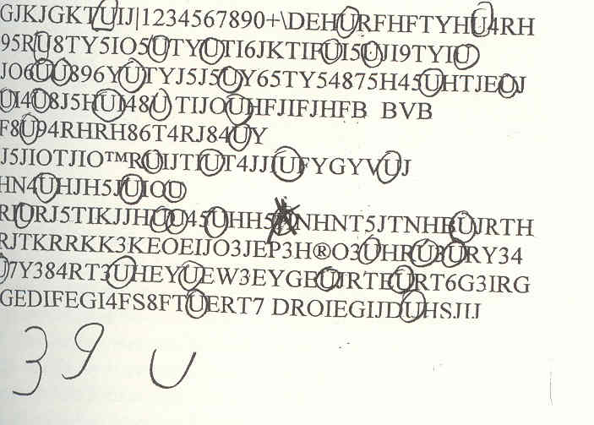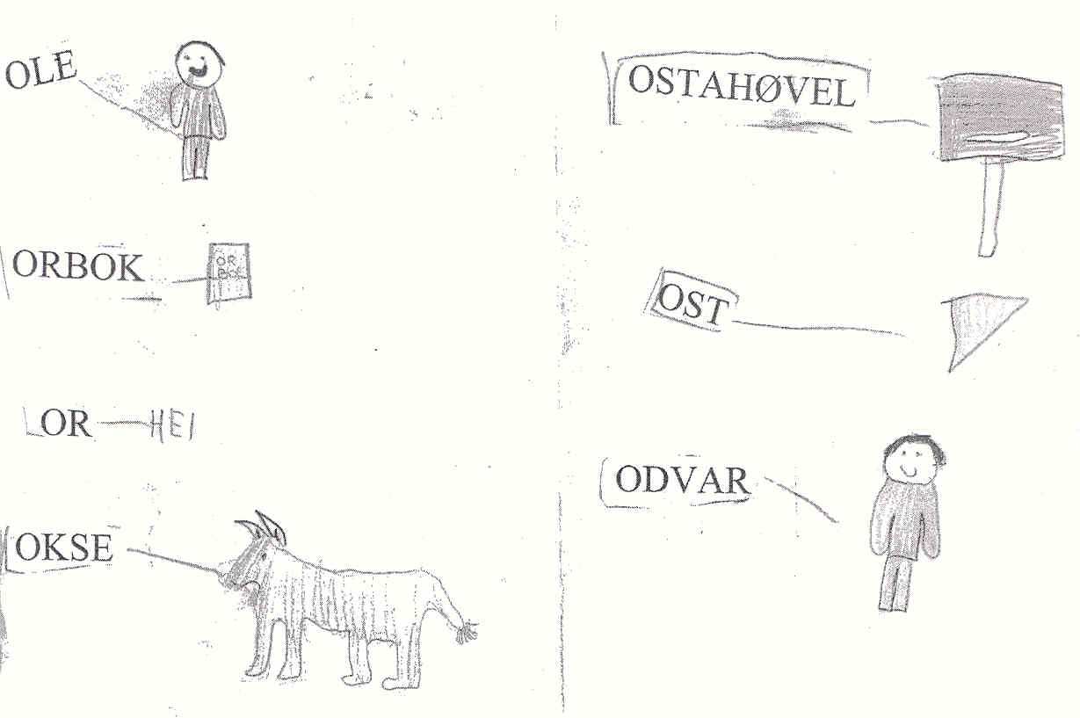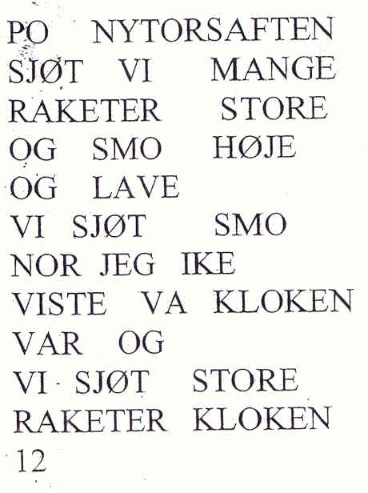
Letter strings. Letter hunting Dictionary Story
Grade 2. The formal teaching of letters and reading through ABC books, traditionally used in grade 2 in Norway, became unnecessary. The children simply continued to write and read. The playful writing and reading (Liang & Johnson, 1999) exploded at the beginning of the school year. The children, working in pairs, became assistant “teachers” for their partners, discussing technical problems and content in their writing. Capital letters were now regarded as “childish”. They used lower case letters, like “real books” they said. 2,700 texts provided background for analyzing literacy development in grade 2. Newspaper production, reading books, and letters were the most important genres used in grade 2.
When the students played “publishing house,” the production of ABC books became popular. Students created easy reader books suitable for different reading levels. The authors wrote books on different themes, from classical fairy tales to modern science fiction. One class produced 100 textbooks in two months. Rich class libraries became important.
Playing “newspaper office” with an editor, journalists, and layout people became an inspiring challenge. Using the computer enabled students to produce a more professional layout. The newspaper below had 12 pages, including national and local disasters, sports, jokes, school activities, a story about working for a child centre for homeless children in Brazil, and comic strips.

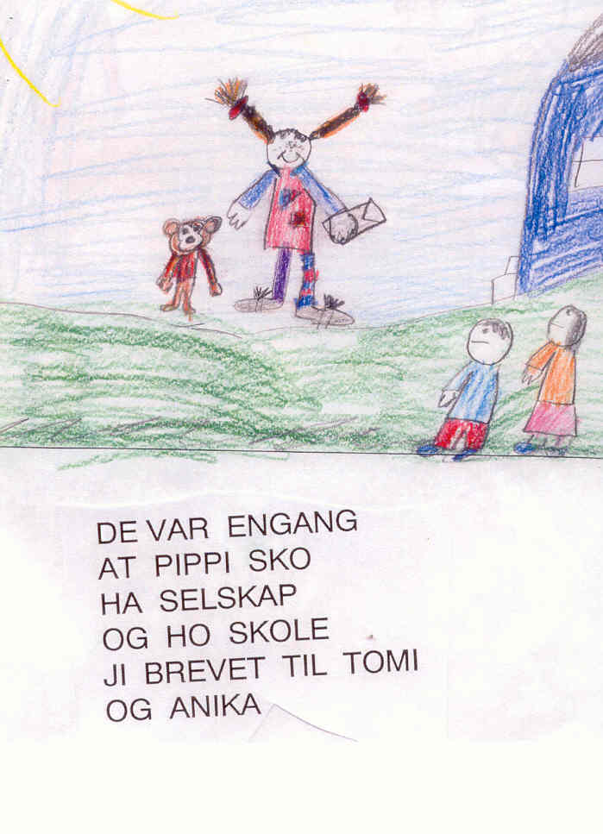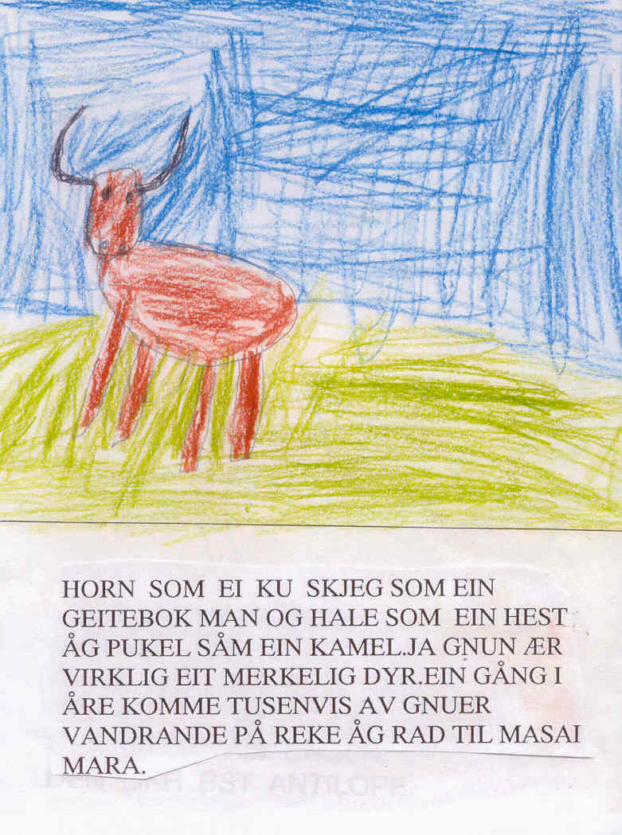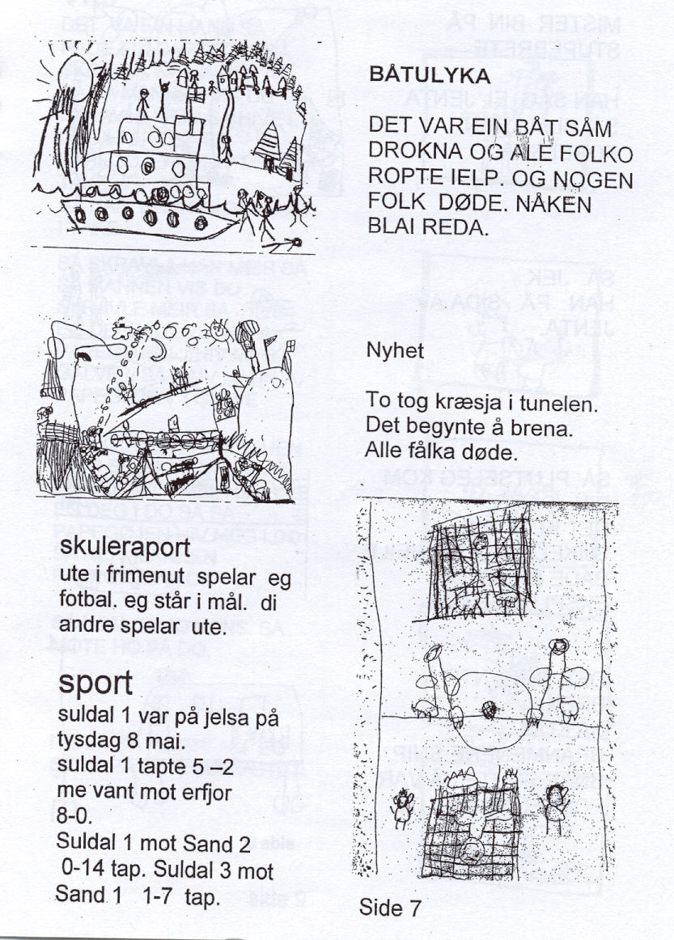
ABC books: Pippi, 5 pages Wild animals in Africa, 6 pages Newspaper: News, sport p.4

Grade 3. The children continued to use the most central genres at a more advanced level and divided into more sub-genres. The books produced became more varied and serious within the genres of factual prose and fiction, as well as in many subgroups and creative combinations of genres. The boys were inspired by action films, comics, and horror books, while the girls
loved fairy tales and romantic literature. Dramatizing script ideas, and drawing the
story before or during writing, heightened the quality of writing. Long lasting cross-disciplinary themes inspired students to enjoy writing. For example, a two-month
theme titled “Flight” included lessons in science, social science, and mathematics, supported
by arts and crafts. The writing during the “Flight” unit covered topics ranging from Greek mythology to birds to modern airports. The process-oriented strategy (Hoel, 2000) raised the quality of writing. Here, computer writing demonstrated its greatest advantage. The first draft got constructive response from the computer partner and the teacher. The child might produce up to 10 revisions of a book of 20–60 pages long, each version building of the response to the previous versions, without difficulty. Using handwriting, this would be impossible. Oral response was still dominant, but written responses were now well established. The 8-year-olds
read longer and more complicated books, often several hundred pages long. They produced reports and book reviews of books by professional authors and by their own classmates.
In newspaper productions, the standards were raised. The classes studied different professional newspapers thoroughly, and had serious discussions about their choice of content, picture placement and size, titles, layout, ingresses, and plain texts. The total size of the newspapers might be 20 pages, richly illustrated with good drawings. Rich variety of content and the objective handling of complicated, controversial national and international matters demonstrated a high level of journalistic competence.

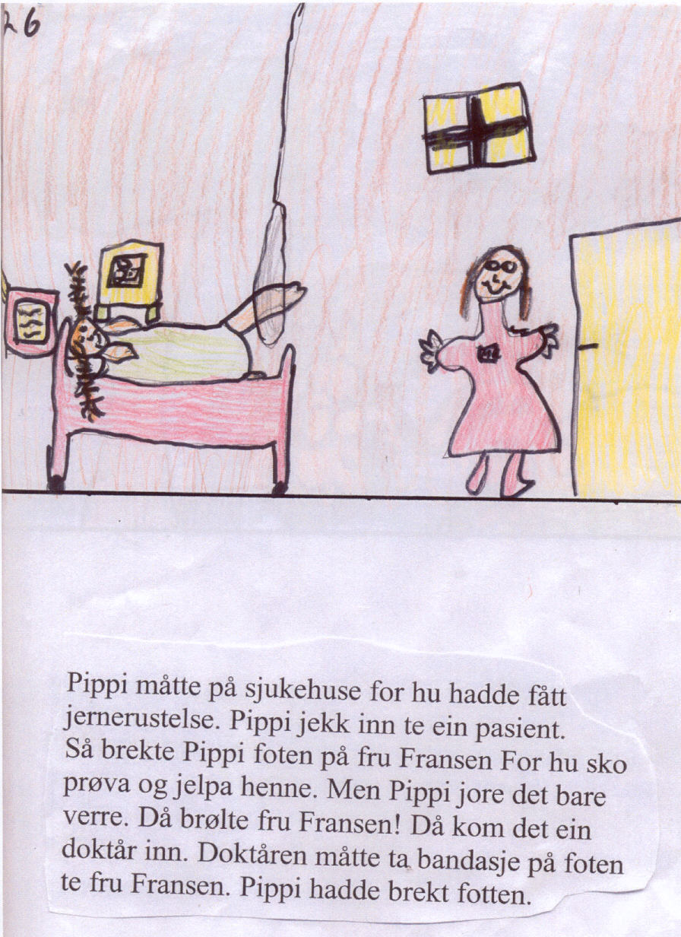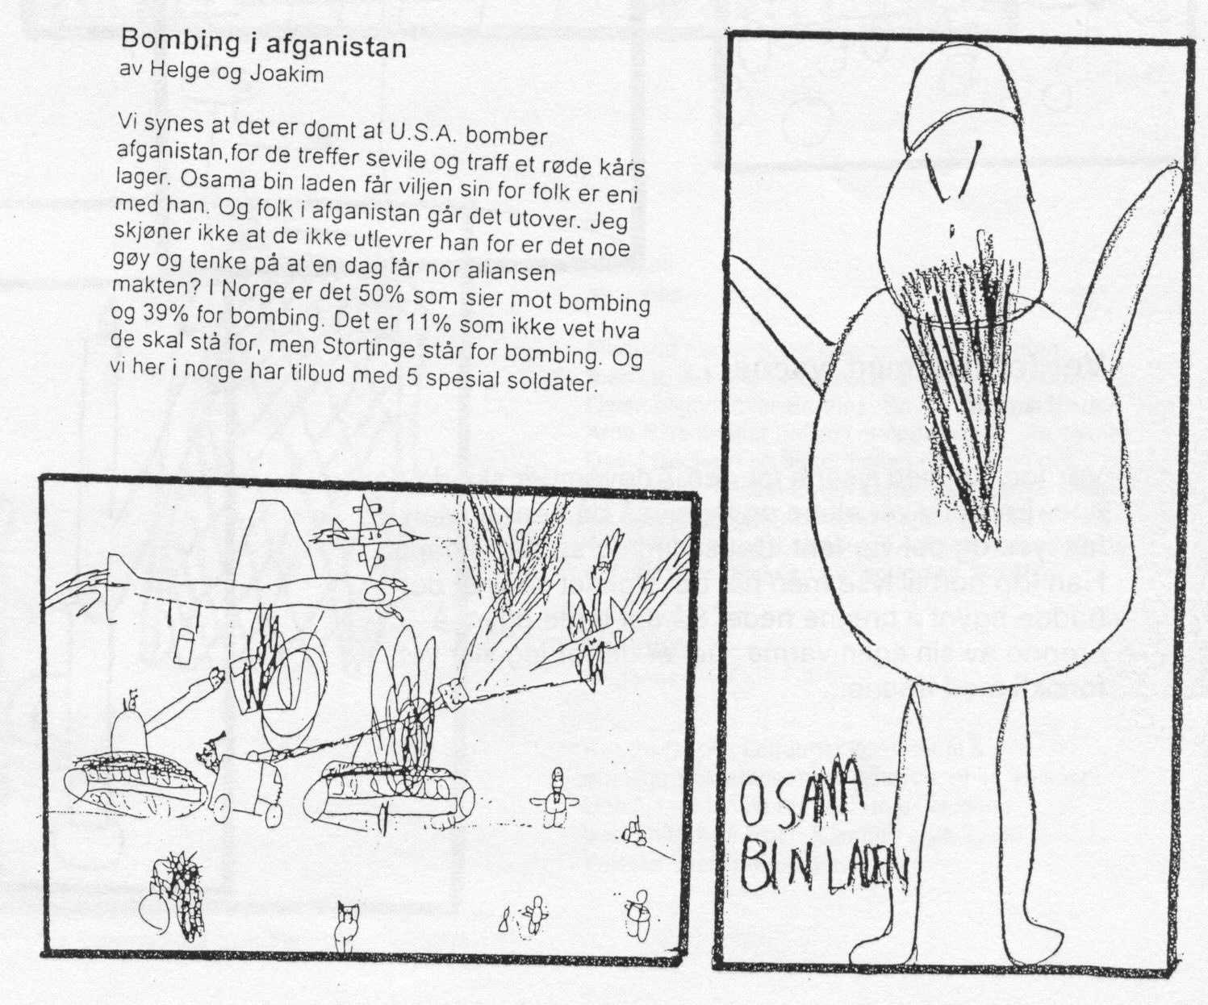
Book: Pippi. Page 26 of 34 pages Newspaper: 16 pages. News. Bombing in Afghanistan
Denmark, Finland, Estonia.
Classes in these countries showed similar development. However, while 6-year olds in Norway continue their elementary education in the same institution, children in other countries change institutions, from preschool for the 6-year olds, to primary school for the 7-year olds. The children changed institutions and teachers, and discontinuity was a problem.
The Danish grade 1 students (7-year olds) began the project in the middle of the
year because of the late installation of computers in the classroom, and the change of
teachers. The writing level was lower than in the Norwegian classes. But by grade 2
(similar to grade 3 in Norway), the children showed a similar developmental level in
their writing compared to students in Norwegian classes. The teachers felt that computer
writing made it easier for children from multicultural backgrounds (8 different mother tongues) to learn Danish as a foreign language.
The Finnish class had Swedish as their mother tongue. Their writing level was high, and their reading skills impressive. The children changed physical environments from “preschool/kindergarten” for 6-year olds to grade 1 in primary school when they became 7 years old, as in Denmark. But the preschool teacher was here allowed to follow the children into grades 1 and 2.
In Estonia, the project became a kindergarten project for the oldest children in the
3- to 7-year old group. We could not follow the same children for 3 years, as we did
in the other countries. The level of writing was amazingly high. For example, one 6-
year old started making a book about a bull and a cow. The preschool teacher expected
the book to be 10 pages long when completed! At the end of the project, the classroom teacher followed up the work in grade 1 (Lang, 2003).Her class was divided into six groups, five of which were working in the classroom, with the sixth group in the library writing on four computers. A special computer teacher assisted them.

Test of Writing Level. End of Grade 3
This evaluation answered the fourth question posed at page 2:
“Will a concentration on computer writing in grade 1 and 2 and delaying the formal teaching in handwriting to grade 3, give better results in written language?”
International reading tests (IEA) are regarded as relatively valid and reliable, but
writing tests are controversial. The IEA writing test for grades 6–9 resulted in cultural
disagreement about what was a “better” written composition (Allard & Sundblad 1991, Purves 1992). However, national guidelines are developed. In England, the Implementation of the National Literacy Strategy (DEE, 1997) gives some guidelines for writing for Key stage 1 (9 years). The United States has a long tradition of evaluating the quality of children’s texts (Gorman et. al.1988). Evaluation of the American computer writing project WTR used different scales for 6- to 7-year olds (Chamless & Chamless 1993). Different U.S. states present norms for “good” writing. The “Pennsylvania State Curriculum in Writing” has developed detailed guidelines for writing from Kindergarten to grade 6. Descriptions of acceptable writing for grade 3 include the following:
• Composes pieces that develop a problem or central idea and flow from beginning,
middle to end
• Adapts writing style/form to maintain focus on topic, purpose and/or audience
(stories, letters, journals, poems, plays)
• Includes literacy elements in narratives (characters, setting, problem, major
events, solution)
• Writes complete sentences (subject + verb) using end punctuation appropriately
(periods, exclamation points, question marks) most of the time
In Norway, there was strong resistance to use a predefined set of norms. A holistic evaluation based on connoisseurship was used. According to Eisner (1994) connoisseurs of a subject tend to show a high agreement in a holistic evaluation of what is a “good” and “bad” level in that area (here, the subject was the text productions of the children).

Content Quality Test
Eight computer classes and nine handwriting classes were assigned two 40-minute
writing tasks: “Create a fairy tale,” and “Describe a visit to the dentist.” The handwritten
pieces were transcribed into printed computer form, and mixed randomly with responses
from computer classes. Two experienced language teachers in teacher education made
a holistic scoring of the content quality of 594 texts on a scale from 1 – 4, where the
highest score is 4. The agreement between evaluators was high.

 | Dentist visit |  |  | Fairy tale
 | Boys | Girls | Total | Boys | Girls | Total
Computer classes | 2.16 | 2.54 | 2.33 | 2.27 | 2.43 | 2.32
Handwriting classes | 1.78 | 2.28 | 2.05 | 1.85 | 2.24 | 2.05

The results show clearly higher scores for the computer classes in writing tasks by both boys and girls, with the highest difference in scores for the boys. The results correspond with Keetley (1997). All differences are significant at the p<0.001 level. The boys’ scores are lower than the girls overall, but in four classes the mean score was alike. Limitations to note
are that the compared classes are statistically only a stratified sample, and that an experiment group often tends to get better results than the control group (Hawthorne effect).

Handwriting Test
The most controversial aspect of the project was delaying the formal teaching of handwriting
to grade 3. Would this delay be negative for students’ handwriting? A test compared the quality of the handwriting between computer classes and traditional handwriting classes. Two experienced specialists on handwriting in primary school made a holistic assessment of the quality of the handwriting on a scale 1 – 4, where 4 was highest. The agreement between evaluators was high. Results:

Quality of handwriting
Computer classes: 2.74
Handwriting classes: 2.45

How many words written in a minute?
PC classes: 4.35
Handwriting classes: 4.91

In spite of delayed formal teaching and a much shorter training time in handwriting, the computer classes documented better quality in handwriting, but a bit slower speed. The differences are significant at the p<0.001 level. The delay in introducing formal instruction in handwriting was most profitable for boys.

The website for the project (www.hsh.no/home/atr/tekstskaping) gives more detailed
evaluations, an English commented video to describe the total strategy, English articles in addition to the Norwegian, and a representative selection of about 1.000 texts (of the 7.500), shows the development in computer writing from grade 1 – 3.

Conclusion
The child as consumer of information technology dominates the research. The child as producer is seldom researched. My project is dominated of the child as producer within the CSCL paradigm (Koschmann, 2001). It is not IT, but ICT where communication is the keyword. This is in tune with the constructivist and socio interactionist view of learning in our National Curriculum. Developing new methods for literacy learning in Lower Primary School is the main result of the project (Trageton, 2003b& 2005b).
For the last hundred years, the reading aspect of literacy has dominated, with the old debate about the strengths and weaknesses of the whole language versus the phonic approach
in reading. In this project, the writing aspect of literacy has been the starting point. The traditional READING- and writing teaching was revolved 180 degrees to WRITING- and reading learning. Writing is easier than reading (Chomsky, 1982, Clay, 1975, Hagtvet 1988, Sulzby 1989). To use the computer as a writing tool, instead of the complicated handwriting, made this “revolution” possible. The letters in writing and reading are identical when typed, and the way from writing to reading was made easier by this similarity. The children learned to read from their own text production. Because writing came first, they could use the strengths and reduce the weaknesses of the 3 classical reading methods. The results are in tune with the WTR project in the United States (Chamless & Chamless, 1993). However, their equipment and strategy was too complicated, rigid and costly (Singh, 1993) compared with the playful use of the cheap, recycled computers used in our Nordic project.

Høien (1996) stresses decoding as the central factor in reading:

Reading = decoding x understanding

When children are writing to read, however, instead of decoding, they start with under- standing and the easier coding of their own thoughts in the writing/reading process:

Understanding x coding x decoding = reading of meaningful text

When children are writing or reading a meaningful text grown out of their own thinking and imagination, they will, in addition, develop letter knowledge, use individual combinations of the phonics and whole language reading methods, and the understanding of the total text becomes meaningful language. After reading their own texts, children advance to read unknown, but meaningful texts produced by their peers, and later from interesting books in the library. This is the theoretical explanation why “Writing to Read” seems more effective than starting by reading foreign texts from an ABC primer (Willows, 1988). The task becomes more motivating for the child. Writing and reading are knit tightly together. The further writing is stimulated by intense reading from the library, from newspapers, and from other sources. Writing stimulates reading. Reading stimulates writing in different genres. The process-oriented strategy to raise the quality of the texts (Hoel, 2000) becomes much easier, because computer writing allows repeated revisions and editing without difficulty before publishing for their own class library, local community or internet.

Reading research and reading tests dominate the international debate. Reading
tests have been obligatory for all Norwegian schools since 2004 in grade 2, 3, 4, 7 and 10. In 2005 for the first time we got writing tests for grade 4, 7 and 10. For the first time writing tests for grades 4, 7, and 10 (Berge & Vagle, 2003) became obligatory in Norway in 2005. This may become the start of a new Centre for Writing Research parallel to the existing Centre for Reading Research. Hopefully, this will produce a better balance between writing
and reading research. In my opinion “International Reading Association” ought to be changed to “International Literacy Association”.

The mass implementation 2002-2006
How to spread the playful “Writing to Read” strategy in the Nordic countries?
The strategy behind the project has been a combination of action research, action learning and school development (Tiller 1999). This is also the key strategy for the mass implementation. Because of the good results of this project, many communities in Norway want to implement and improve this literacy strategy for grades 1–4. Another reason is that the strategy is also in tune with the demands in our new National curriculum 2006. The plan presents 5 basic competencies in all subjects:

Orally expression. Written expression. Reading. Mathematics
Digital competence (produce, compose and publish own multimodal texts)

The expression and production comes first (not reading), and also the digital competence will strengthen the writing side of literacy. My playful “Writing to Read” strategy cower 4 of the 5 basic competencies in lower primary school.
Textbooks, videos, website
Learning materials for teachers are important. The pioneer project gave background for writing a textbook for teacher education (Trageton 2003b). Shortened and adjusted versions are translated to Danish 2004 and Swedish 2005. A Finnish version is coming in 2007. Planning for a Kurdish version has started. In the pioneer project good contacts with parents was very important. They were strong supporters for modernising the school. Teachers together with the parents and their organisations play an important role in school development and implementation of the new National Curriculum 2006. Therefore I also made a book for parents about the essential in the playful computer strategy in Writing to Read. (Trageton 2005c).
Of the 60 videos produced in the pioneer project, I have chosen 18, re-edited them and published them at 3 DVD discs, showing different classes in action in computer writing in grade 1, 2 and 3 (post@av-senteret.no). The videos are effective materials for students and teachers as inspiration for implementation of this writing and reading strategy in own class.
The website consist of video examples from the project, from TV news in Norway, Denmark, Sweden, articles in Norwegian and English, reports from newspapers and magazines mainly from the Nordic countries. A database of 1000 chosen texts from grade 1- 3 shows the development of the writing.

Courses
The most effective strategy for implementation and school development is a combination of pressure from both top and bottom. The town Bergen is a good example. The ICT counsellor for the town sent a letter to the principals for all 65 primary schools in Bergen if they were interested to start this strategy. The principals must talk with their teachers in grade 1 to find out if they were interested. 18 schools wanted to start in 2002. The teachers got a day course; the principal had the responsibility for installing 4 recycled computers and a printer in every classroom. In a follow up course in October, the teachers presented their experiences in the start period for the other schools for inspiration and debate. A third course was held after a year to exchange experiences and discussing consequences for the next year in grade 2. Next year 43 schools wanted the same strategy, and in 2005 this strategy became obligatory for all 65 schools in Bergen. www.gs.bergen.hl.no/tekst Many smaller towns and communities followed the example of Bergen.
At Vahl multicultural school in Oslo students at PC learn to write and read on their mother tongue before translating to Norwegian. From grade 2 they are producing textbooks in two languages: Arabic->Norwegian, Urdu->Norwegian, Turkish-> Norwegian and Somali->Norwegian. 8 Sámi schools in Finmark produce Sámi textbooks from grade 2 and 3. The computer writing strategy is via courses spread to hundreds of classes all over Norway and Denmark. In Sweden there have been 80 courses the last years for 9000 teachers and students in teacher education. Hundreds of teachers have started to practice the strategy. (See for instance www.gr.to/attskriva) One was a mother tongue teacher in Kurdish and Arabic in Ørebro. She took contact with the minister of Education in the Kurdistan Region in North Iraq. We became invited there for a week where we held 3 courses for 500 teachers and students at the University. The Minister started Oct. 2006 a similar project with 4 schools in Kurdistan, and he want the Norwegian textbook translated to Kurdish. Perhaps Chemnitz might be interested in a similar German project?

New research
Will new research confirm or contradict the pioneer results?
I like the OECD definition: Research is a combination of pure research, applied research, innovation and implementation. Action research and learning start often at the bottom with innovations to change praxis. Teachers and students start to make small reports on a lower level. This can be the background for master degrees, doctoral studies and post doctor research. While there is a hundred years tradition of reading research, we have only 30 years writing research, and in a tiny degree. We have in Norway a solid “Centre for Reading research”, but up to now, no “Centre for Writing research”. Research about computer writing for 5-9 year olds is very seldom in the Nordic countries, an exception is Folkesson (2005) evaluating computer writing 6-9 year olds in one class, and found similar results as in my project. It is therefore important that the new innovations are followed up with research.
Besides my work there are only a few studies in Norway. Alant et.al (2003) found higher level on texts written on computers in grade 3, more motivation and collaboration. Helleve (2001) studied the discussions among the pairs behind each computer about what to write. She found that the oral language got a very advanced level when the students succeeded in cooperating around a common text. Grimsø (2003) followed her own class for 3 year and made a thorough qualitative analysis of the development. Onarheim (2006) made a qualitative study of the interaction student-student-teacher around the printed texts. 5 master degrees in “ICT in learning” at Stord/Haugesund University College are finished, 4 of them just evaluating the development in Bergen. (Salomon et al. 2004, Vavik 2003, Aasheim 2005, Paulsen 2005, Sandal 2005, Sørensen 2005) I only show a little bit of the master thesis about the writing tests in grade 2 (Paulsen 2005). The texts were scored of three independent evaluators. 4 is top level, 3 over middle, 2 below middle, and 1 is bottom level

Fairy tale. Comparison PC classes – Handwriting classes

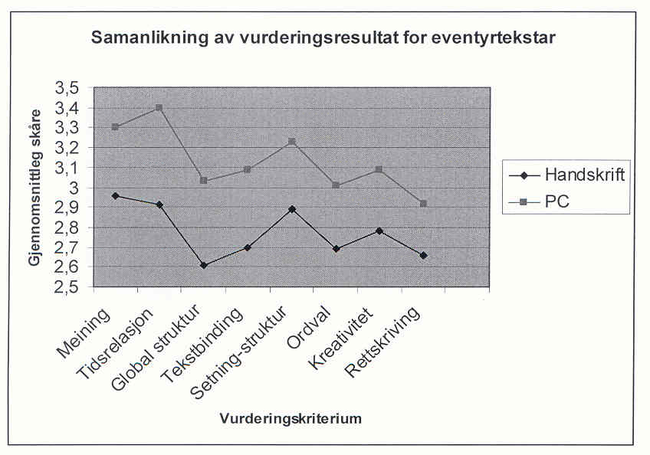
The children got in the spring 2004 the same writing tests in grade 2 as the pioneer classes had in grade 3. in 2002. Also in grade 2 the PC classes wrote significant better texts at than the handwriting classes on all components: Meaning, time relation, global structure, text binding, sentence structure, word variations, creativity and correct spelling. The difference was greatest at the fabulous text: Compose a fairy tale. (p<0.001 level)

Length of texts

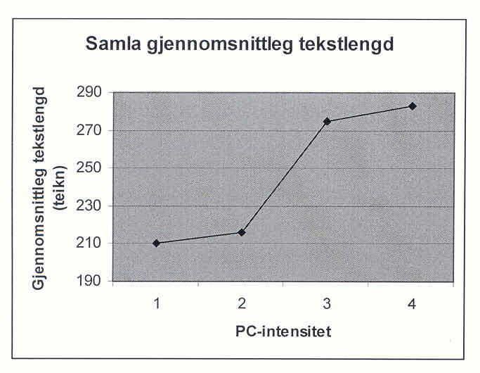
1. Hand writing, no computers
2. Computer on day a week in a computer lab
3. Computer some days a week in the classroom
4. Always access to computer writing in the classroom
PC classes also wrote longer texts, 252 words in mean. The handwriting classes wrote 210 words in mean. In classes where the children had max access to the computers the whole week in the classroom, the mean was 290 words (Paulsen 2005).
In the reading test however (Aasheim 2005), there was no difference between PC classes and hand writing classes. The problem is that the tests were dominated by decoding. This was in favour of classes using traditional phonic ABC books (Traavik 2002). While decoding tests have a long tradition and high degree of agreement among researchers, we have much less research about comprehension and comprehension tests, and more disagreement among researchers (Myrberg 2004:58). The National Reading tests in Norway 4. Grade 2004-2005 was criticised for missing validity for reading comprehension, and was withdrawn.

Future research possibilities?
In this new praxis for “Writing to Read by computer” I see possibilities for hundreds of different master- and doctoral thesis in computer science, pedagogic, special education, psychology, linguistic, literature, anthropology, didactics in different school subjects etc.

Some rough ideas:
Will PC writing also in Grade 4 give better results than hand writing?
Are the results specific for the first studies? For Norway? Replication in other countries?
Comparative studies: Differences in development Kurdistan-Sweden?
Effects in foreign language learning? Arabic->Norwegian, Norwegian->English…
What are the conditions for implementation in a school, community, a whole country?
The touch writing system on PC: What effect on writing has the dominance of kinesthetic/tactil senses? On different students, different learning styles?
Quite opposite handwriting will computer writing with both hands on the key board send signals to both brain halves. What effect on the electronic patterns in the brain, thinking and language learning?
What is the effect of different keyboard training programs?
What is the effect of the Dvorak keyboard instead of the traditional QWERTY keyboard?
What effect on computer writing using Latin, Arabic, Chinese, Japanese keyboard etc?
What are the effects of computer writing on ADHD children, deaf children, blind children, motor invalid children, socio-emotional problems …?
What are the effects on oral language in the pair discussion behind the computer?
Linguistic analysis of thousands of electronic texts
What genre combinations, superstructure, inter texts, multimodal texts in the PC texts?
All texts are illustrated with drawings or paintings. Will the quality of drawings correspond with the quality of texts?
Will dramatizing of stories give better computer texts?
Will out door school give better computer texts?
What is the relation between a rich library and the computer texts?
Dialect and sociolect variations in the written texts?
Invented spelling, phonologic, orthographic. What is the development in detail?
Longitudinal description of one child’s writing development 6-16 year

This is only some examples of loose research ideas. The next 20 years I hope there will be hundreds of master- and doctoral thesis within this central, but almost blank area of research.

Perhaps the University of Helsinki might be interested in some research, coordinated with the project in Vasa, Åbo akademi?

It was with great respect and humidity I newly presented “Writing to Read by Computer” in Erbil in Kurdistan, the oldest city of the world. The centre of the old civilisations and the start of the Art of Writing and Mathematics were printing signs in clay in their Mesopotamien 6-8000 years ago, not handwriting. By printing texts by computers we go back to basic!

References
Alant, L. B et. al.(2003) Samhandling med, foran og via skjermen. (Collaboration with, behind and via the computer screen) ITU rapport nr 18 Oslo
Allard, B., & Sundblad, B. (1991). Skrivandets genes under skoltiden. (Development of writings during school). Stockholm: Stockholm universitet, Ped. institutionen.
Berge, K.L., & Vagle, W (2003). Utvikling og utprøving av nasjonale prøver i skriving [Development of national tests in writing]. Oslo: Universitetet i Oslo, Prosjektbeskrivelse.
Brostrøm, S (1995) 6-9 års pædagogik. Leg, leg, rammeleg (Play, play, frame play) Århus: Systime. Denmark
Chamless, J., & Chamless, M. (1993). The effects of instructional technology on academic achievement of 2nd grade students. Oxford: University of Mississippi.
Chomsky, C. (1982). Write now, read later. In C. Cazden (Ed.), Language in early childhood education (pp. 141–149) Washington, DC: National Association for the Education of Young Children.
Christie et.al (1999) Play in a Literacy-Enriched Play Center in Same-age and Multi-age Grouping Arrangement.
TASP conference. New Mexico. USA
Christie, J & K. Roskos (2001) Research on play and literacy – a critical review. ICCP World Play Conference Erfurt. Germany
Clay M (1975) What did I write? Beginning writing behaviour. Heinemann. New Zealand
DEE. (1997). The implementation of the National Literacy Strategy. London: Department for
Education and Skills.
Eisner, E. (1994). Cognition and curriculum reconsidered (2nd Ed.). N. York: Teachers College Press.
Erstad, O. (1998). Innovasjon eller tradisjon [Innovation and tradition]. Oslo: Univ. i Oslo, ITU.
Ervik, A. B. (2004) Play as a basis for stimulating literacy and language in upper primary school in Norway. Paper ICCP Krakow. Poland
Folkesson, A.M (2005) Datorn i det dialogiska klassrummet. Studentlitteratur AB
Goldberg et al (2003) The Effect of Computers on Student Writing: A Meta-analysis of Studies from 1992-2002 The Journal of Technology, Learning and Assessment 2 (1): 2-51
Gorman, T.P., Purves, A.C., & Degenhart, R.E. (1988). IEA Volume 5. New York: Pergamon Press.
Grimsø, I. (2003) Du bare legger fingrene sånn. Hovedfag pedagogikk Høgskolen i Oslo
Hagtvet, B. (1988) Skriftspråksutvikling gjennom lek. (Literacy through play) Universitetsforlaget. Oslo
Hall, N. & L. Abott (eds) (1991) Play in the Primary Curriculum. Hodder & Stoughton. London
Hartmann W (1988) Spiel und elementares Lernen. Österreichischer Bundesverlag. Wien
Healy, J.M. (1998). Failure to connect: How computers affect our children’s minds—for better and worse. New York: Simon & Schuster.
Helleve, I. (2001) Samspel med data? (Collaboration behind the computer) Hovudfag i pedagogikk. Bergen
Hoel, T. Løkensgard. (2000). Skrive og samtale. Responsgrupper som læringsfellesskap [Writing and
conversation: Response groups as learning community]. Gyldendal, Norway: Akademisk.
Huizinga,J. (1955) Homo Ludens. A study of the play element in culture. London/Boston: Beacon Press
Høien, T. (1996). Avkodingsstrategier og leseutvikling[Decoding strategies and reading development]. In Austad (red) Mening i tekst. LNU/Cappelen Akademisk.
Karlsdottir, R. (1998). Utvikling av lese- og rettskrivingsgferdigheter hos grunnskolebarn i Trondheimsområdet. (Development of reading and spelling skills by school children in Trondheim area) I Learning strategies and skill learning. Skrift 4 s 93-109. Det kgl. norske videnskabers selskab. Trondheim.Tapir.
Keetley, E. (1997). Comparison of first grade computer assisted and handwritten process story writing. Master’s dissertation, Johnson and Wales University. (ERIC Document Reproduction Services No. ED384882)
Koschmann, T. (Ed.). (2001). CSCL: Theory and practice of an emerging paradigm. Mahwah, NJ:Erlbaum.
Kulik, J.A. (2003) Effects of Using Instructional Technology in Elementary and Secondary School. SRI International. Project number P10446.001
L 97 Læreplanverket for den 10 -årige grunnskolen (The National Curriculum 1997) KUF.
L 2006 Læreplan for grunnskolen og videregående opplæring (The National Curriculum 2006)
www.odin.dep.no/filarkiv/255552/lplan
Lave, J., & Wenger, E. (1991). Situated learning: Legitimate peripheral participation. New York:
Cambridge University Press.
Liang, P., & Johnson, J. (1999). Using technology to enhance early literacy through play. Computers in the Schools, 15(1), 55–64.
Lillemyr O F (2003) Play in School – The Teacher’s Role. Reforms and Recent Research. In Saracho & Spodek (red) Contemporary Perspectives of Play in Early Childhood Education. Greenwich. Connecticut: Information Age Publishing Inc.
Lorentzen, R. T. (1999)Barns skriftspråksutvikling. Moslet, I. red. Norskdidaktikk-ei grunnbok s 94-109.Tano A
Ludvigsen, S. (1999). Informasjons- og kommunikasjonsteknologi, læring og klasserommet.
[Information and communication technology, learning and the classroom]. Bedre skole, 2.
Moyles, J (1994) The Excellence of Play. Open University Press. Buckimham
Myrberg, M.(2004) Att förebygga och möta läs- och skrivsvårigheter.En forskningsöversikt. Skolverket. St. holm
Onarheim, E.N.B. (2006) Møte med tekst (Meeting with texts) Master thesis Pedagogic. University of Bergen
Pessanha, A (1995) Comparative Study of Play ICCP/TASP conference Salzburg
Piaget, J. (2001) The psychology of intelligence (M. Piercy & D.E. Berlyne, Trans.). London: Routledge.
Purves, A.C. (Ed.). (1992). The IEA study of written composition II: Education and performance in fourteen countries. Oxford: Pergamon Press.
Retter, H (1983) Spielen – Arbeiten – Lernen. Spielmittel nr. 5 Germany
Salomon, G., et al. (2004). Computers and writing. In T. Nunes & P. Bryant (Eds.), Handbook of children’s literacy (pp. 409–442). Boston: Kluwer.
Schrader, C.T. (1990). The word processor as a tool for developing young writers (Journal Code
RIEDEC1990). (ERIC Document Reproduction Service No. ED321276)
Singh, B. (1993). IBM’s Writing to Read program: The right stuff or just high tech fluff? ERIC No. ED339015
Sulzby, E. (1989). Assessment of writing and of children’s language while writing. In L. Morrow & J.
Smith (Eds.) The role of assessment and measurement in early literacy instruction (pp. 83–109).
Englewood Cliffs, NJ: Prentice-Hall.
Sutton-Smith, B. (1990) Dilemmas in adult play with children. ICCP conference Germany
Sutton-Smith, B. (1997) The Ambiguity of Play. Cambridge. Massachusetts
Søby, M. m.fl. (2005) ITU monitor. www.itu.no/itu_monitor
Trageton A (1997) Leik i småskolen. (Play in lower primary school) Fagbokforlaget
Trageton, A. (2001). Creative writing on computers:Playful learning, Grade 1. Erfurt, Germany: ICCP.
Trageton, A. (2002). Creative writing on computers:Playful learning, Grade 2. Santa Fe, NM: The
Association for the Study of Play.
Trageton, A. (2003a). Creative writing on computers:Playful learning, Grade 3, End results. Copenh.: NFPF.
Trageton, A. (2003b). Å skrive seg til lesing. IKT i småskolen [Writing to read: ICT in lower Primary School]. Oslo. Universitetsforlaget.
Trageton, A. (2005a) Play in Lower Primary School in Norway. In Lytle, Mc Mahon, Sutton-Smith:
Play & culture studies vol 6 pp 157-179 Lanham, Maryland : Univ.Press of America
Trageton, A. (2005b) Creative writing on computers: 6- to 10-year olds. Writing to Read. In Pandis, M et al: Reading, Writing , Thinking. Proceedings of the 13th European Conference on Reading pp 170-177. International Reading Association. Newark. DE. USA
Trageton, A. (2005c) Skriv på PC – lær å lese (Write at computer – learn to read) PEDLEX. Oslo
Traavik, H. (2002) Nye ABC-er. Mye å velge mellom. Utdanning nr 29/30 s 60-61
Vavik, L. (2003). Writing to read with ICT support. Research description. Stord/Haugesund University College
Vygotsky, L.S. (1978). Mind in society: The development of higher psychological processes . M. Cole, V. John-Steiner, S. Scribner, & E. Souberman, Eds. & Trans.). Cambridge, MA: Harvard University Press
Wassermann S (2000). Serious players in the primary classroom 2nd ed. NY. Teachers College Press
Willows, D.M. (1988). Writing to read as a new approach to beginning language arts instruction.
Toronto, ON: University of Toronto, Ontario Institute for Studies in Education.

Ei komparativ studie av tradisjonell lese- og skriveopplæring og pc-støtta skrive- og leselæring. Masteroppgåver. IKT i læring. Stord/Haugesund University College
(Studies of traditional reading- and writing teaching and computer-based writing- and reading learning.
Master thesis ICT in learning)

Aasheim N. J. (2005) Lesedugleik. (Reading level) Stord/Haugesund University College
Paulsen E. S.(2005) Skrivedugleik. (Writing level) Stord/Haugesund University College
Sandal A. K. (2005) Lærarhaldningar. (Teacher attitudes) Stord/Haugesund University College
Sørensen R (2005) Observasjon av prosessar i klasserommet. (Observations in the classrooms) Stord/Haugesund

