Associate professor (retired) ATEE Winter Conference 2010

Arne Trageton e-mail: arne.trageton@hsh.no Early Years, Primary Education

Stord/Haugesund University College and ECT
5414 Stord, Norway Prague. Czeckia Feb. 26-28. 2010

Writing to Read.
Playful computer writing. Grade 1. - 4. (6- 9 year olds)
1999-2002. Mass implementation 2002-2010

Computer research in school/preschool is common, but few study computer writing for 5-9 year olds, and almost none combine such studies with play research and creativity research.
Problem: Will playful computer writing and delayed handwriting to grade 3 give better writing results?
Through action research in 14 classes in Norway, Denmark, Finland and Estonia 1999-2002, the 6 year olds developed writing/reading in grade 1 through playful computer writing. Traditional textbooks in grade 2 became unnecessary, school library important. They produced their own textbooks by playing “authors” “Publishing house” and “Newspaper office”. In grade 3 they composed more complicated books in different genres and advanced newspapers. The writing stimulated intensive reading.
The development is documented by 7500 texts and 60 edited videos. PC classes showed higher quality in composing fairy tale and factual prose than handwriting classes, significant on p>0.001 level. Surprisingly, also the handwriting tests showed significant higher quality in the PC classes on p>0.001 level, in spite of the delayed handwriting and much shorter exercise time. The results may lead to radical changes in literacy learning. www.hsh.no/home/atr/tekstskaping
The strategy now spreads to hundreds of schools in Norway, Denmark, Sweden and Finland. A textbook for teacher education (Trageton 2003 b) is translated to Danish, Swedish, Finnish. 25 master degrees and the start of 2 doctoral studies is the only research since my project. Preschools in the Nordic countries have also used this strategy for 4-5 year olds.

Is computers in school good for learning? It depends! To provoke I will say: Computer consumer programmes reduce learning! Only the child as producer may increase learning.

Background
Consumer ideology
Politicians have a naïve belief that more computers give more learning and have spent billions of euros for computers and software. But PISA show: More computers-less learning (Wössmann & Fuchs 2004) Computers are often misused in a consumer ideology based on old behaviourism, heavily sponsored by the computer industries. The old software programs follow the traditional stimulus – response model. The program control the child, like the traditional teacher in asking yes- no questions. A meta study of 300 computer research reports gave little, none or negative learning effect (Healy 1998). She report serious damages to children’s concentration and learning from using program packs within a behaviouristic consumer ideology. Jonassen (2000) found that 85 % of “pedagogic software programmes” in school were of this behaviouristic consumer character, harmful for learning.

Producer ideology
Quite opposite, the Norwegian National Curriculum from 2006 regards the student as producer and communicator of his own knowledge. The fundament for our new NNC 06 is 5 basic competencies in all subjects: Orally expression. Written expression. Reading. Mathematics and the new Digital competence (produce, compose and publish own multimodal texts). Similar, EU proclaim 2006 eight key competences:
1. Communication-mother tongue
2. Com.-foreign languages
3. Mathemath/science/technology
4. Digital competence
5. Learning to learn
6. Intercultural/social/civic
7. Entrepreneurship
8. Cultural expression
1. Communication start with expressing yourself oral and written. This is a central democracy question also. Within 4. Digital competence the student should produce, compose, present and exchange communication.
Text production by computers became richer, longer, more varied, with higher reflection and arguing level, more collaboration and feedback than handwriting at grade 1-12. Erstad (2005) The creative expression and production is central. The most used tool for that in school is the computer writing function, also in grade 9 (Vavik 2009). Also outside school writing is the dominating producer tool in most age groups through e-mail, SMS, chat, blogging, face book etc.
The Nordic National Curriculums also follow a constructivist and socio-cultural view of learning (Lave & Wenger 1991, Piaget 2001, Vygotsky 1978) and computer-supported collaborative learning paradigm (CSCL) in computer research (Koschmann, 2001).
My playful and creative “Writing to Read” strategy cover 4 of the 5 basic competencies in lower primary school in all subjects in Norway. Besides the EU key competences: Communication-mother tongue and digital competence, the strategy also stimulate Communication-foreign language, Learning to learn, Intercultural/social/civic, Entrepreneurship and Cultural expression.

Research problem
Will playful computer writing (6-9 years) and delayed formal teaching of handwriting until 8 year olds give better results in written language?

Playful computer writing - Writing to Read
30 years research document that writing is easier than reading for 4-7 year olds, and should come before reading (ex. Clay 1975, Chomsky 1982, Hagtvet 1988). The school have instead in 160 years been teaching Reading and writing. The handwriting is difficult for 5 – 7 year olds. The easier writing on computers solve the problem. Formal handwriting was delayed until grade 3 in Norway (grade 2 other Nordic countries) Teachers and children used a more playful and informal approach than the American WTR, (Chamless & Chamless 1993).They used recycled computers only as type writers.

What is Play?
Play is: Action, symbolizing (Comenius 1634). Children’s Art(Schiller 1793). Highest expression of human development (Frøbel 1826). Central for emotional development (Eriksson 1971). Central in cognitive growth (Piaget 1946). Develop abstract thinking (Vygotsky 1933-1978). Communication (Bateson 1976). and most important: Culture production (Huizinga 1955, Gadamer 1965, Sutton-Smith 1990) Reference Trageton 1995, p 19-20

Play – Writing - Computers.
The earlier Norwegian National Curriculum (L97) was the most playful curriculum in the world (Trageton 2005a). Play as cognitive development (Piaget/Vygotsky tradition) gives effective learning through play (Pramling 2007). The playing child as culture producer is quite opposite the “child as consumer” attitude. Preschool level dominates in play research. Few research projects document the effect of play in Primary School (except Retter 1983, Hartmann 1988, Moyles 1995, Pessanha A 1995, Trageton 1997& 2005a, Christie et al. 1999, Wassermann 2000, Lillemyr 2003).
Lindquist (1995) examine the connections play-drama-literature in preschool. Christie & Roskos (2001) document the effect of play on emergent literacy in preschool. Christie & Stone (1999) follow up the same strategy among 6-8 year olds. I advocate a similar play learning climate in lower primary school.
What about play and computers? Most computer projects in schools are dominated of a consumer ideology, quite opposite to play. Liang and Johnsen (1999) however, conclude that computer software may give valuable development and learning for the 5-8 year olds, if the children become producers following the play criteria:
- Positive affect
- Intrinsic motivation
- Process more important than product
- “As if” or non-literal attitude
- Exploration

For the 6-10 year olds not only the process, but also the product becomes important for long lasting quality play (Trageton 1997& 2005a).
Demands to software:
- Open ended problem-solving oriented
- Developmental appropriate in practice
- Strong relation to play

Open ended tool programmes like word-processing gives the children billions and billions of possibilities to play with various letter combinations, words, sentences, stories by only pushing 26 letters, major and minors, many fonts, sizes, different lay out possibilities.

Creativity - Computer writing
The old intelligence tests measured convergent intelligence, in tune with traditional school teaching and tests for “right answers”. Guilford (1950) heavily criticised these tests, and constructed new intelligence tests for divergent thinking, or creativity tests. In the 1970ties there was a huge flow of creativity research defining the creative processes as: Divergent thinking, idea richness, flexibility, originality, fluency, flow, openness, intuition, experimenting, problem solving, entrepreneurship, playful, humorous, artistic, (Cropley 1967). These characteristics fit also well for play. In the 1990ies the international testing in Reading/Mathematics returned “back to basics”, i.e. convergent thinking, and forgot the creativity. Many IEA tests was dominated of the convergent thinking type, with one “right answer” in multiple choice tests.

After 2000 there have been a strong criticism of this one-sided test types, and IEA tries to develop more sophisticated tests. But for instance Reading comprehension is very complicated to measure in a multiple choice test, marking the “right answer” in a multiple meaningful text. In Writing tests “right-wrong” is of course meaningless. IEA “gave up” to compare the creative writing in 14 countries in the 80es, because of disagreement around the criteria for “good” and “bad” texts in different countries (Gorman 1988)
Today therefore, only a restricted part of the curriculum is tested. The central oral and written expression is not tested. Social science, cultural and aesthetic disciplines, play and creative laboratory experiment is not tested, and have been heavily reduced in all European countries.

The criticism above have now given a new wave of creativity research (Csikszentmihalyi, M. 1996, 2000) and arguments for more playful learning, social/cultural/ aesthetic processes and knowledge production in the curriculum over viewing central life themes from several subjects’ point of view, and also within a single subject. Europe need creative humans!
In UK for instance, a government initiative scheme since 2002 have released £150 million for 1500 primary and secondary schools working with over 330,000 young people and over 4,500 creative practitioners.

… nurturing ways of thinking and working that encourage imagination, independence, tolerance of ambiguity and risk, openness, the raising of aspirations… (Creative Partnerships, 2005b, para.2)

Creative processes gives a flow combining divergent/convergent thinking, so the children use his total intellectual capacity in learning. This is not measured at the IEA tests. Bamford (2006) compare the impact of the Arts on the PISA results. Countries where culture/art subjects had a broad position and high quality in schools, also scored high on the PISA tests, for instance Finland. English Ofsted report from 44 schools document that creative approach raise standards http://www.ofsted.gov.uk/Ofsted-home/Publications-and-research/Browse-all-by/Documents-by-type/Thematic-reports/Learning-creative-approaches-that-raise-standards According to Hargreaves and Shirley (2009), creative processes among children and adults is necessary for educational change in school development and sustainable development.

In Playful computer writing there is no “right answers”. The children, mostly in pairs, use their creativity, experiments, idea richness, originality, fluency, flow, humorous, artistic sense to discuss, communicate and produce very divergent texts using 26 letters, different fonts, sizes, layout. The verbal texts are combined with their own divergent, fiction/faction/ factual, detailed drawings/paintings together in multimodal texts. (Kress 1997, 2003) After the first sketch they make convergent critical responses in the process orientated writing to structure and correct the text better and better. This gives billions of possibilities for artful process/production in letter combinations, wordbooks, fairy tales, factual prose, newspapers etc. around the essential parts of the curriculum with in all subjects.

Earlier research
Computer projects in school from 1970-2000 was dominated of the child as consumer. Projects about the child as producer were rare. ERIC (2000) reported 20,000 research projects in primary schools. Only 20 were about creative writing on computers for 5- to 7-year olds! Most referred to the huge “Writing to Read” (WTR) programme. Chamless & Chamless (1993) reported very positive results.

Setting - Methods
The project was three years action research in 14 classes in Norway, Denmark, Finland, and Estonia. The Norwegian classes dominated. The children were followed from grades 1 – 4. (Because school start at 6 years in Norway, this was similar to preschool classes-grade 3 in the other countries) All schools had 2 – 10 recycled, inexpensive computers in corners in the classroom, only equipped with a word processing program, knit to an old printer.
The methods were:
Naturalistic observation and video recording in the 14 classes over 3 years (60 edited videos)
Collecting the text productions of the children into an electronic database (7500 items)
Reports and interviews of the class teachers
Questionnaires for children and parents in the end of the project
Tests in composing written stories. End grade 3
Tests of the quality of handwriting. End grade 3

The development of writing. Qualitative results. (Trageton, 2003b, 2005b).

Norway. Grade 1. (6 year olds)
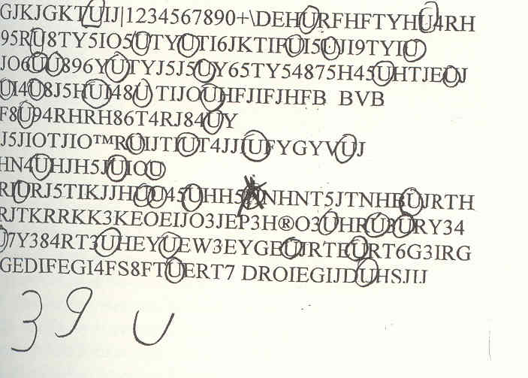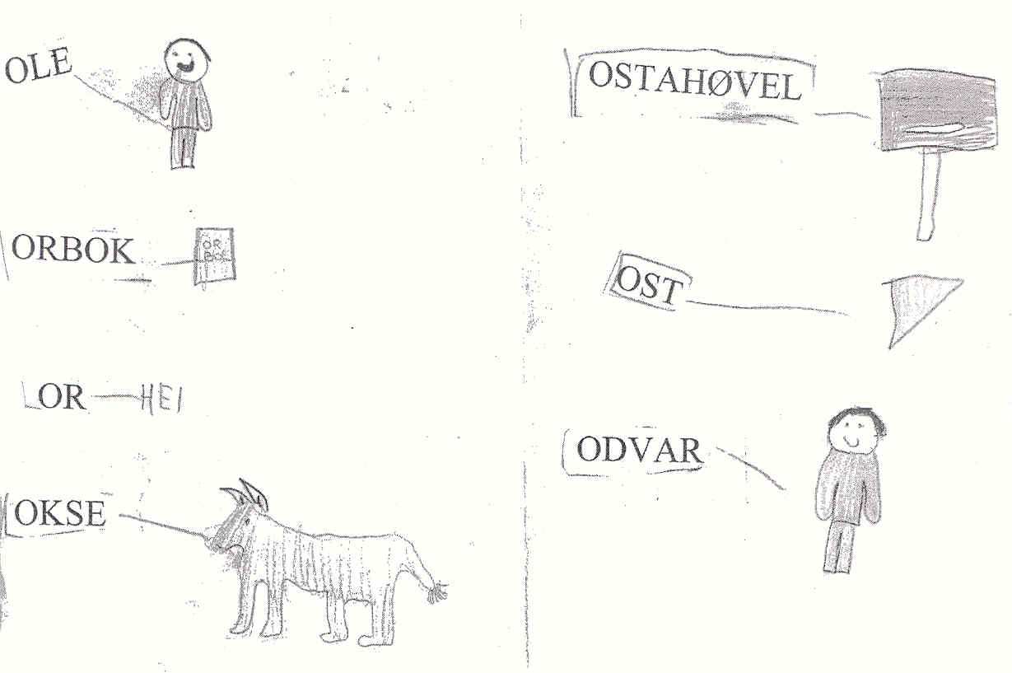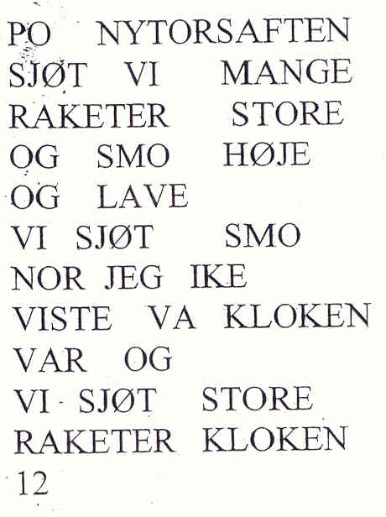
Letter strings. Letter hunting Dictionary Story

Through examining 1,500 texts written by grade 1 students (6-year olds),
I mapped the development of spontaneous computer writing for the first time
in the Nordic countries. The development was rather similar to the better established research
in spontaneous handwriting development (Sulzby, 1990). But the progression went faster, because some steps in handwriting do not exist for computer users. The mechanics of computer writing are easier also. The results are close to Schrader’s (1990) in the United States. She concluded that the development of writing on the computer was similar to that of handwriting for 4-7 year olds, but went much faster than in handwriting, because some problems were solved by the computer (standard lettering, line direction and line shift). Through playful writing, the children learned 24 capital letters and 20 lower case letters in grade 1 as a mean score. Karlsdottir (1998) concluded that letter knowledge by the age of 7 was the most important factor in predicting reading ability in grade 4. The children also wrote words, short texts and stories. Through their own writing all of them also learned to read in grade 1. (6 year olds)

Grade 2. (7 year olds).
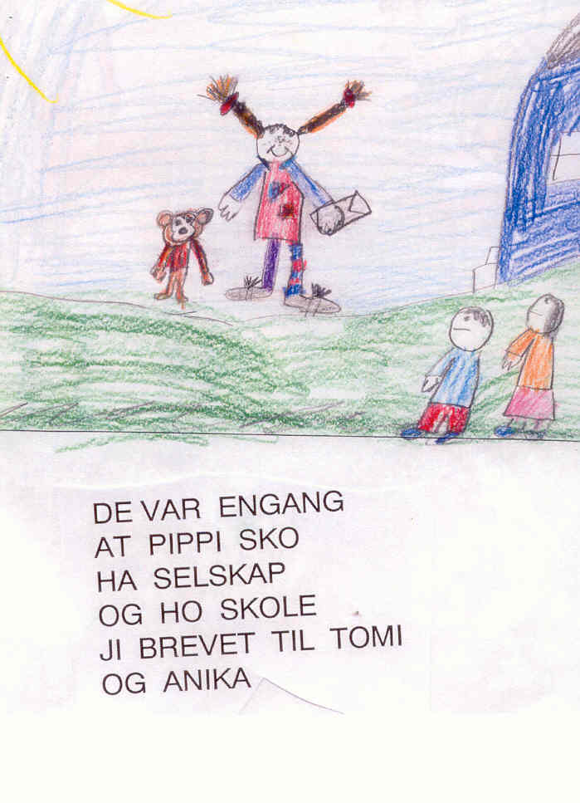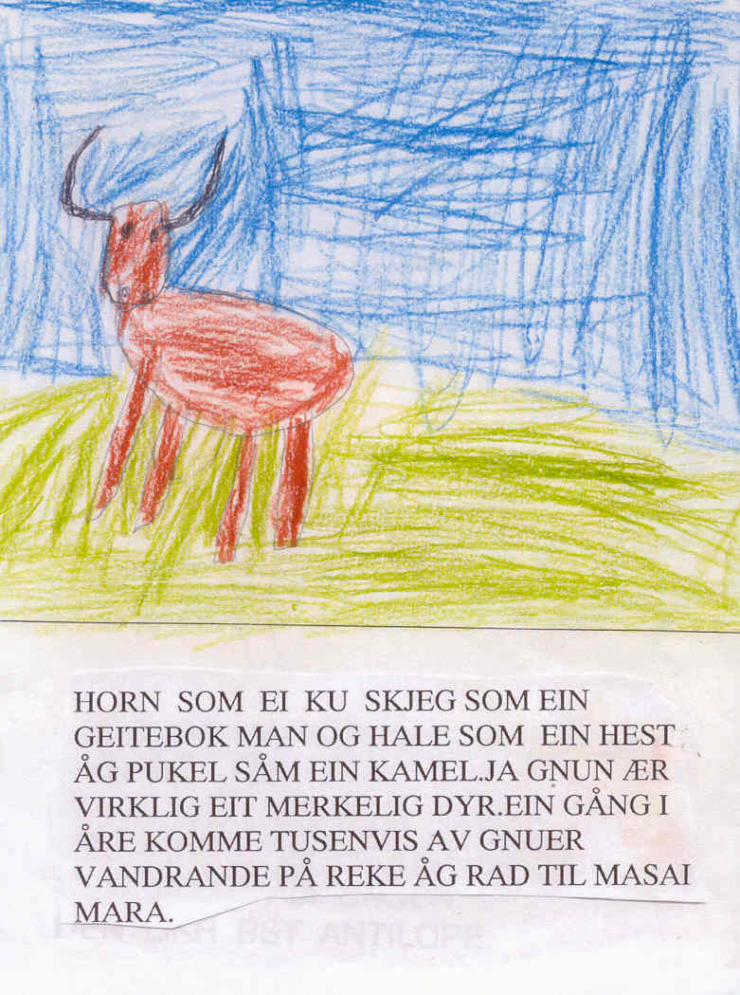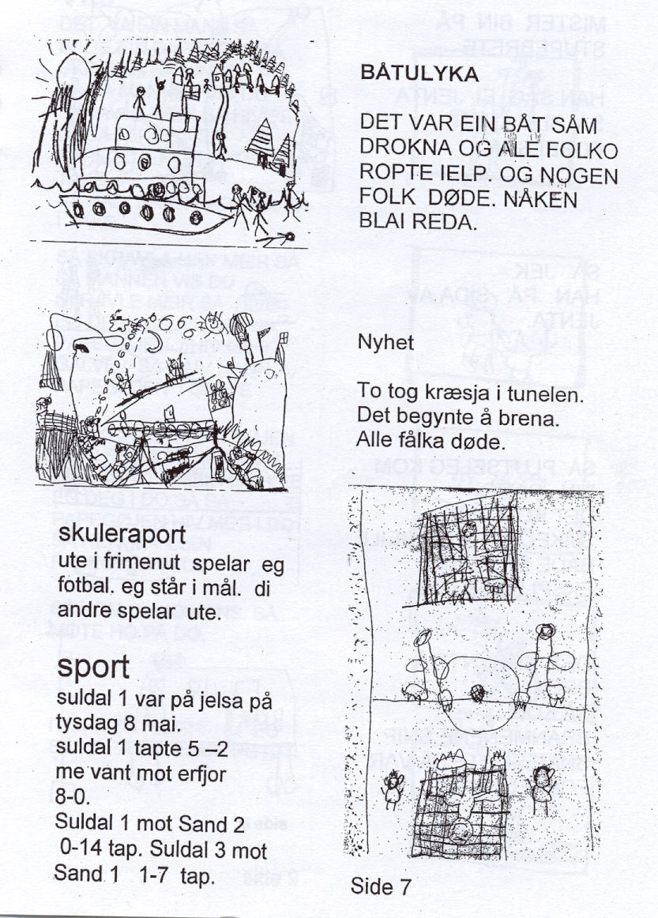
Reading books: Pippi, 5 pages Wild animals in Africa, 6 pages Newspaper: News, sport p.4

The formal teaching of letters and reading through ABC books/primers traditionally used in grade 2 in Norway, became unnecessary. The children simply continued to write and read. The playful writing and reading (Liang & Johnson, 1999) exploded at the beginning of the school year. The children, working in pairs, became assistant “teachers” for their partners, discussing technical problems and content in their writing. Capital letters were now regarded as “childish”. They used lower case letters, like “real books” they said. 2,700 texts provided background for analyzing literacy development in grade 2. Newspaper production, reading books, and letters were the most important genres used.
When the students played “publishing house,” the huge production of easy reading books became popular, suitable for different reading levels. The authors wrote books on different themes, from classic fairy tales to modern science fiction. One class produced 100 textbooks in two months. Rich class libraries became very important.
Playing “newspaper office” with editor, journalists, and layout people became an inspiring challenge. Using the computer enabled students to produce a more professional layout. The newspaper above had 12 pages, including national and local disasters, sports, jokes, school activities, a story about working for a child centre for homeless children in Brazil, and comic strips.

Grade 3. (8 year olds).

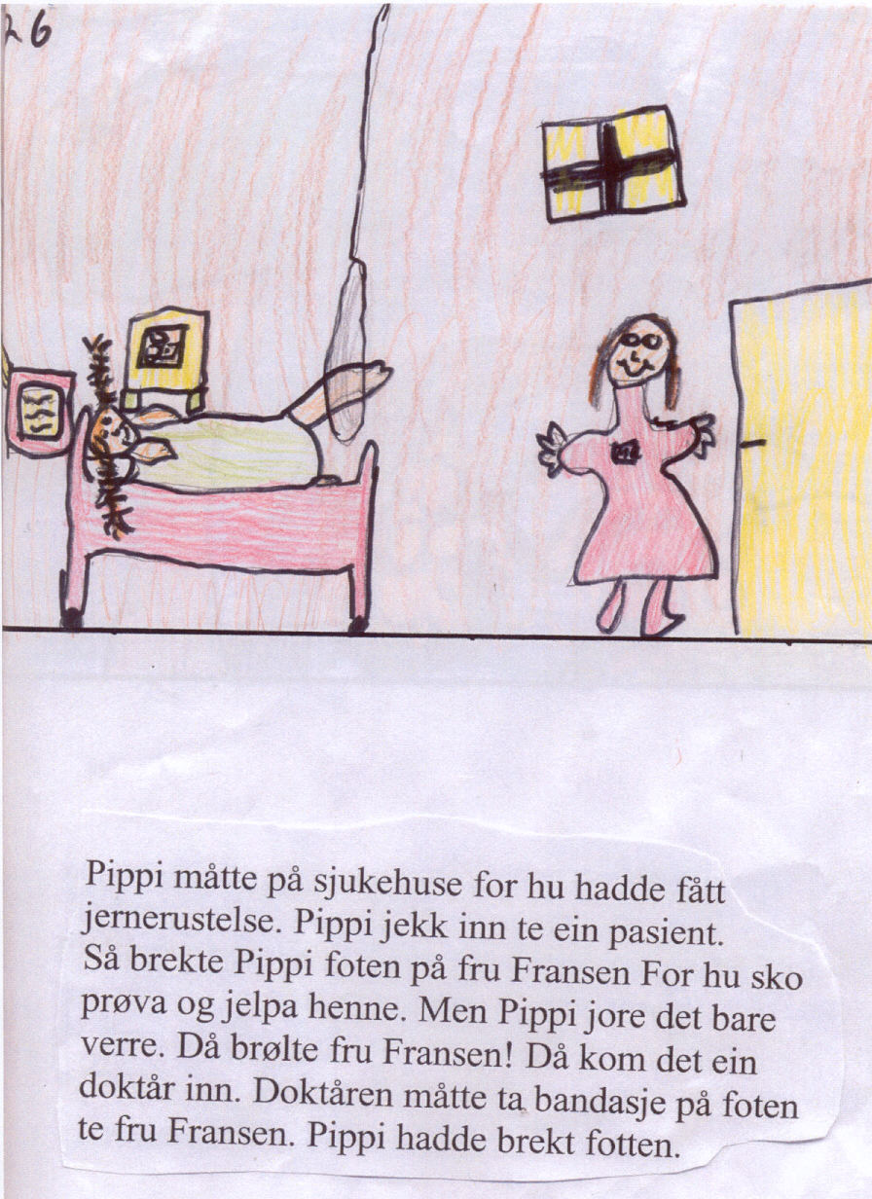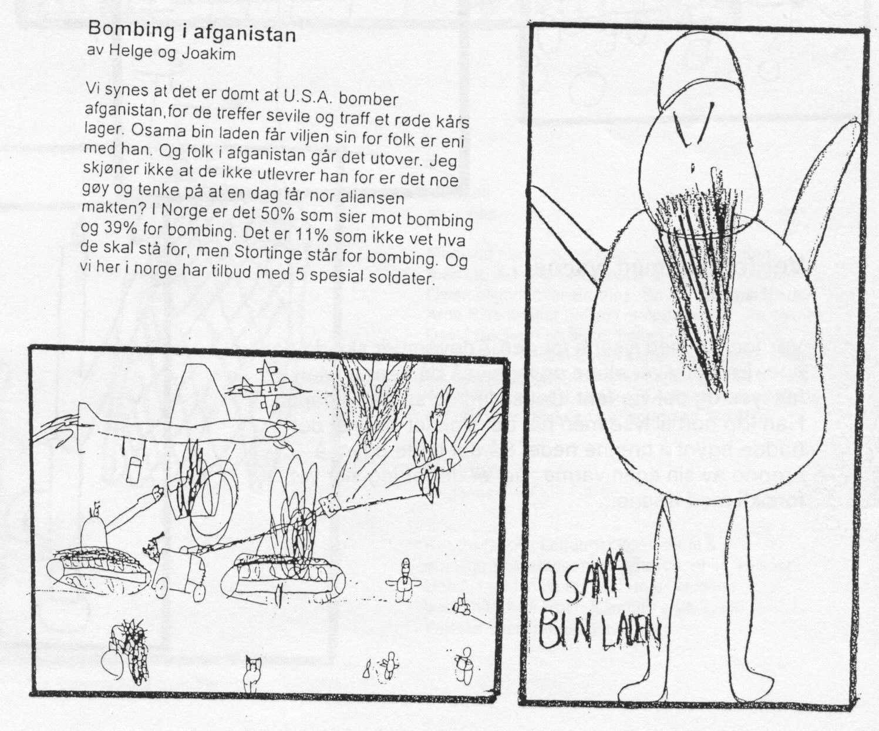
Book: Pippi. Page 26 of 34 pages Newspaper: 16 pages. News. Bombing in Afghanistan
The children continued to use the most central genres at a more advanced level, divided into more sub-genres. The books became more varied and serious within the genres of factual prose and fiction, as well as in many subgroups and creative combinations of genres. The boys often were inspired by action films, comics, and horror books, while the girls loved fairy tales and romantic literature. Dramatizing script ideas, and drawing the story before or during writing, heightened the quality of writing. Long lasting cross-disciplinary themes inspired students to enjoy writing. For example, a two-month theme titled “Flight” included lessons in science, social science, and mathematics, supported by arts and crafts. The writing during the “Flight” unit covered topics ranging from Greek mythology to birds to modern airports. The process-oriented strategy (Hoel, 2000) raised the quality of writing. Here, computer writing demonstrated its greatest advantage. The first draft got constructive response of the first draft from the computer partner and the teacher. This was a good background for the second revised version. The child might produce up to 10 revisions of a book of 20–60 pages long. Each version was adjusted after the response to the previous versions, without difficulty. Using handwriting, this would be impossible. Oral response was still dominant, but written responses were now well established. The 8-year olds read longer and more complicated books, often several hundred pages long. They produced reports and book reviews of books by professional authors and by their own classmates.
In newspaper productions, the standards were raised. The classes studied different professional newspapers thoroughly, and had serious discussions about their choice of content, picture placement and size, titles, layout, ingresses, and plain texts. The total size of the newspapers might be 20 pages, richly illustrated with good drawings. Rich variety of content and the objective handling of complicated, controversial national and international matters demonstrated a high level of journalistic competence.

Denmark, Finland, Estonia.
Classes in these countries showed similar development. However, while 6-year olds in Norway continue their elementary education in the same institution, children in the other countries change institutions and teachers- from preschool for the 6-year olds, to primary school for the 7-year olds. Discontinuity was a problem.
The Danish grade 1 students (7-year olds) had a break in the project to the middle of the year, because of the late installation of computers in the classroom, and change of
teachers. The writing level was lower than in the Norwegian classes. But by grade 2
(similar to grade 3 in Norway), the children showed a similar developmental level in
their writing as students in Norwegian classes. The teachers felt that computer
writing made it easier for children from multicultural backgrounds (8 different mother tongues) to learn Danish as a foreign language.
The Finnish class had Swedish as their mother tongue. Their writing level was high, and their reading skills impressive. The children changed physical environments from “preschool/kindergarten” for 6-year olds to grade 1 in primary school as in Denmark. But the preschool teacher was here allowed to follow the children into grades 1 and 2, so they got better continuity. The children were very disciplined in their work and showed high standard.
In Estonia, the project became mostly a kindergarten project for the oldest children in the 3-7 year old group. Two computers were placed on the loft room to get a more peaceful corner divided from the more lively play corners on the ground floor. We could not follow the progression of the same children systematic over 3 years, as we did in the other countries, but the progression for the 5-6 year olds was similar to the Norwegian 6 year olds. The level of writing was amazingly high.

Test of Writing Level. End of Grade 3
This evaluation answered the question posed at page 1:

Will playful computer writing (6-8 years) and delayed formal teaching of handwriting until the age of 8 give better results in written language?

International reading tests (IEA) are regarded as relatively valid and reliable, but
writing tests are more controversial. The IEA writing test for grades 6–9. resulted in cultural
disagreement about what was a “better” written composition (Allard & Sundblad 1991, Purves 1992). However, national guidelines are developed. In England, the Implementation of the National Literacy Strategy (DEE, 1997) gives some guidelines for writing for Key stage 1 (9 years). The United States has a long tradition of evaluating the quality of children’s texts (Gorman et. al.1988). Evaluation of the American computer writing project WTR used different scales for 6- to 7-year olds (Chamless & Chamless 1993). Different U.S. states present norms for “good” writing. The “Pennsylvania State Curriculum in Writing” has developed detailed guidelines for writing from Kindergarten to grade 6. Descriptions of acceptable writing for grade 3 include the following:
• Composes pieces that develop a problem or central idea and flow from beginning,
middle to end
• Adapts writing style/form to maintain focus on topic, purpose and/or audience
(stories, letters, journals, poems, plays)
• Includes literacy elements in narratives (characters, setting, problem, major
events, solution)
• Writes complete sentences (subject + verb) using end punctuation appropriately
(periods, exclamation points, question marks) most of the time

In Norway, there was strong resistance to use a predefined set of norms. A holistic evaluation based on connoisseurship was used. According to Eisner (1994); connoisseurs of a subject tend to show a high agreement in a holistic evaluation of what is a “good” and “bad” level in that area (here, the area was the text productions of the children).

Content Quality Test
Eight computer classes and nine handwriting classes in Norway were assigned two 40-minute
writing tasks: “Create a fairy tale,” and “Describe a visit to the dentist.” The handwritten
pieces were transcribed into computer print, and mixed randomly with responses
from computer classes. Two experienced language teachers in teacher education made
a holistic scoring of the content quality of 594 texts on a scale from 1 – 4, where the
highest score is 4. The agreement between evaluators was high.

 | Dentist visit |  |  | Fairy tale
 | Boys | Girls | Total | Boys | Girls | Total
Computer classes | 2.16 | 2.54 | 2.33 | 2.27 | 2.43 | 2.32
Handwriting classes | 1.78 | 2.28 | 2.05 | 1.85 | 2.24 | 2.05

The results show clearly higher scores for the computer classes in writing tasks by both boys and girls, with the highest difference in scores for the boys. The results correspond with Keetley (1997). All differences are significant at the p<0.001 level. The boys’ scores are overall lower than the girls, but in four classes the mean score was alike. Limitations to note
are that the compared classes are statistically only a stratified sample, and that an experiment group often tends to get better results than the control group (Hawthorne effect).

Handwriting Test
The most controversial aspect of the project was delaying the formal teaching of handwriting
to grade 3. (grade 2 in other countries). Would this delay be negative for students’ handwriting? A test compared the quality of the handwriting between computer classes and traditional handwriting classes. Two experienced specialists on handwriting in primary school made a holistic assessment of the quality of the handwriting on a scale 1 – 4, where 4 was highest. The agreement between evaluators was high. Results:

Quality of handwriting
Computer classes: 2.74
Handwriting classes: 2.45
How many words written in a minute?
PC classes: 4.35
Handwriting classes: 4.91
In spite of delayed formal teaching and much shorter training time, surprisingly the computer classes documented better quality in handwriting, but a bit slower speed. The differences are significant at the p<0.001 level. The delay in introducing formal instruction in handwriting was most profitable for boys.

The website for the project www.hsh.no/home/atr/tekstskaping gives more detailed
evaluations. Video have an English commented video to describe the total strategy, an English commented video from Estonia, from multi-language education and other videos. English articles may be useful, and a representative selection of about 1.000 texts (of totally 7.500), shows the development in playful computer writing from grade 1 – 3.

Conclusion
The child as consumer of information technology dominates the earlier research. The child as producer is seldom in research. My project is dominated of the child as producer within the CSCL paradigm (Koschmann, 2001). In ICT, communication is the keyword. This is in tune with the constructivist and socio-interactionist view of learning in our National Curriculum and EU key competencies. Developing new strategies for literacy learning in Lower Primary School is the main result of the project (Trageton, 2003b & 2005b).
For the last 160 years, the reading aspect of literacy has dominated, with the old debate about the strengths and weaknesses of Whole language versus Word method, versus Phonic approach in reading. In this project, the writing aspect of literacy has been the starting point. The traditional READING- and writing teaching was revolved 180 degrees to WRITING- and reading learning. Writing is easier than reading (Chomsky, 1982, Clay, 1975, Hagtvet 1988, Sulzby 1989). To use the computer as a writing tool, instead of the complicated handwriting, made this “revolution” possible. The letters in writing and reading are identical when typed, and the way from writing to reading was made easier by this similarity. The children learned to read from their own text production. Because writing came first, they could use the strengths and reduce the weaknesses of the 3 classical reading methods. They must use a combination of whole language, word method and phonics. Their texts started in their thinking as meaningful whole language sentences, but when they should write their sentence down, they must analyze the words in the sentence, and use phonics when they should write down the sounds in the first word in the sentence. The results are in tune with the WTR project in the United States (Chamless & Chamless, 1993). However, their equipment and strategy was too complicated, rigid and costly (Singh, 1993) compared with the playful use of the cheap, recycled, simple computers used in our Nordic project.

Høien (1996) stresses decoding as the central factor in reading:
Reading = decoding x understanding

When children are writing to read, however, instead of decoding, they start with under- standing and the easier coding of their own thoughts in the writing/reading process:

Understanding x coding x decoding = writing/reading of meaningful text

When children are writing/reading a meaningful text grown out of their own creative thinking and imagination, they will, in addition, develop letter knowledge, use individual combinations of the phonics and whole language reading methods, and the understanding of the total text becomes meaningful language. After reading their own texts, children advance to read unknown, but meaningful texts produced by their peers, and later from interesting books in the library. This is the theoretical explanation why “Writing to Read” seems more effective than starting by reading foreign texts from an ABC primer (Willows, 1988). The task becomes more motivating for the child. Writing/reading are knit tightly together. The further writing is stimulated by intense reading from the library, from newspapers, and from other sources. Writing stimulates reading. Reading stimulates writing in different genres. The process-oriented strategy to raise the quality of the texts (Hoel, 2000) becomes much easier, because computer writing allows repeated revisions and editing without difficulty before publishing for their own class library, local community or internet.

Reading research and reading tests dominate the international debate. Reading
tests have been obligatory for all Norwegian schools since 2004 in grade 2, 3, 4, 7 and 10. In 2005 For the first time Norway got writing tests for grade 4, 7 and 10 in 2005 (Berge & Vagle 2003) In 2009 Sweden got writing tests for grade 3 and 5. In 2009 a national Centre for Writing and Research is established in Trondheim. This will be a parallel to the long existing Centre for Reading and Research in Stavanger. Hopefully, this will produce a better balance between writing and reading research in the future. Google Scholar shows that 90 % of the literacy research is Reading, only 10 % about Writing and tiny 0.3% Writing to Read!
The growing interest in Literacy research will hopefully give better place for writing.
The mass implementation 2002-2009
How to spread the playful “Writing to Read” strategy in the Nordic countries?
The strategy behind the project has been a combination of action research, action learning and school development (Tiller 1999). This is also the key strategy for the mass implementation. Because of the good results of this project, many communities in Norway want to implement and improve this literacy strategy for grades 1–4. More important, the strategy is in tune with the demands in our new National Curriculum 2006. As mentioned page 2, NC presents 5 basic competencies in all subjects: Oral expression. Written expression. Reading. Mathematics
Digital competence (produce, compose and publish multimodal texts)
The expression and production comes first (not reading), and the digital competence will strengthen the writing side of literacy. My playful “Writing to Read” strategy cower 4 of the 5 basic competencies in lower primary school.

Textbooks, videos, website
Learning materials for teachers are important. The pioneer project gave background for writing a textbook for teacher education (Trageton 2003b). Adjusted versions are translated to Danish 2004, Swedish 2005 and Finnish 2007. Good contacts with parents is were very important. They were strong supporters for modernising the school. Therefore I also made a book for parents about the essentials in the playful computer strategy in Writing to Read. (Trageton 2005c,). The second reprint of this book also have a chapter about play with letters and words on computers in preschool (Trageton 2010)
60 videos was produced in the pioneer project, 18 of them are re-edited and published at 3 DVD discs, showing different classes in action in computer writing in grade 1 - 3 (post@av-senteret.no) . The videos are effective materials for students and teachers for implementation of this writing/reading strategy in own class.
The website www.hsh.no/home/atr/tekstskaping consist of video examples from all countries in the project, TV news in Norway, Denmark, Sweden, articles in Norwegian and English, reports from newspapers/magazines from the Nordic countries. A representative database of 1000 chosen texts from grade 1- 3 shows the development of computer writing.

Courses
The most effective strategy for implementation and creative school development is a combine pressure from top and bottom. The town Bergen (200 000 inhabitants) is a good example. The ICT counsellor for the town sent a letter to the principals for all 65 primary schools in Bergen and invited interested schools to start. The principals must talk with their teachers in grade 1 to find out if they were willing. 18 schools wanted to start in 2002. The teachers got a day course in June; the principal had the responsibility for installing 4 recycled computers and a printer in every classroom. In a follow up course in October, the teachers presented their experiences in the start period for each others for inspiration and debate. A third course was held after a year to exchange experiences and discussing consequences for the next year in grade 2. Next year 42 schools wanted the same strategy, and in 2005 this strategy became obligatory for all 65 schools in Bergen. Many smaller towns and communities followed the example of Bergen. In Sweden I have had courses for about 14000 teachers and students. Hundreds of schools have started. Many communities use the Bergen model for implementation in most schools in the community. In Finland about 150 teachers have tried this strategy for 1-3 years. In Espoo 25 schools have started, also using the Bergen model. Åland have also used the same model for 19 schools.

Multicultural schools
In Oslo perhaps 20% of the students are multicultural. Vahl school had 92% multicultural students. After a course they let the children learn Writing to Read on their mother tongue on computers, before translating to Norwegian. From grade 2 they are producing textbooks in two languages: Arabic->Norwegian, Urdu->Norwegian, Turkish-> Norwegian and Somali->Norwegian. The best of these textbooks are published for sale.
The following example is the first draft for a page who hopefully later will be a interesting Arabic-Norwegian textbook about the environment around the school.

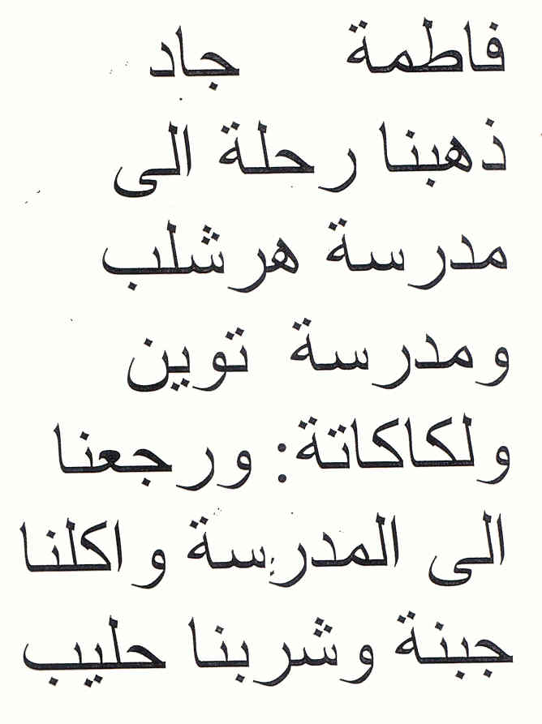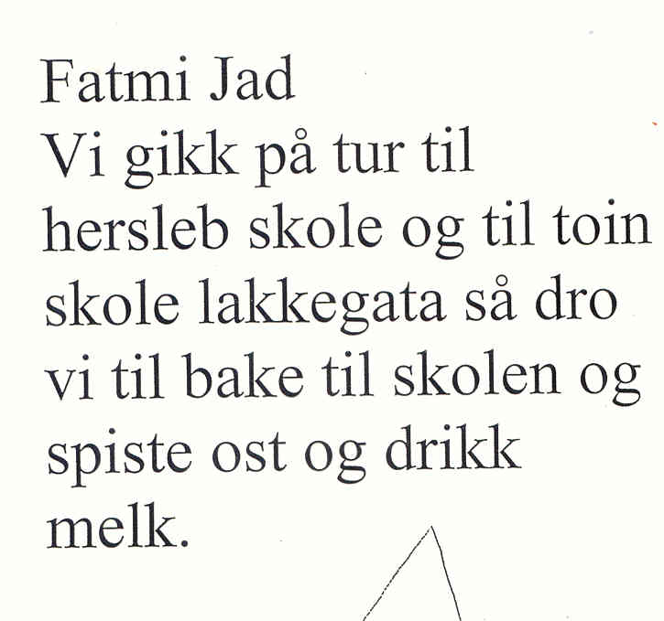

Fatmi & Jad
We went a trip to Hersleb school and to Tøyen school and Lakkegata. Then we went back to our school and ate cheese sandwiches and drank milk.

The mother can read the Arabic version, and the child can be teacher for her mother in learning Norwegian! This may knit the family and school better together.
After a course in Örebro in Sweden, a mother tongue teacher in Kurdish in Ørebro started this strategy in teaching the immigrant children Kurdish->Swedish. She took contact with the minister of Education in the Kurdistan Region in Northern Iraq. We became invited there for a week, where we held 3 courses for 500 teachers and students at the University. The Minister started in 2006 a similar project with 4 schools in Kurdistan. For them Kurdish -> English learning was very interesting. In bilingual Finland the strategy is interesting in Swedish->Finnish and Finnish->Swedish learning. Perhaps some other countries might be interested to use this strategy in bilingual or three-lingual learning? What about research?

New research
Will new research confirm, adjust or contradict the pioneer results?

I like the creative OECD definition: Research is a combination of pure research, applied research, innovation and implementation. Action research and learning start at the bottom, with innovations to change praxis. Teachers and students make small reports on a lower level. (in Sweden 50-60 bachelor thesis) This can be the background for master degrees, (about 25 totally in the Nordic countries), doctoral studies (2 started) and post doctor research. While there is hundred years tradition of Reading research, there is only about 30 years tradition for Writing research in a tiny degree. Norway have a long tradition of a solid “Centre for Reading Research”. First in 2009, we got a national “Centre for Writing Research”.

Research about computer writing for 5-9 year olds is seldom also in the other Nordic countries. An exception is Folkesson (2005) in Sweden, evaluating computer writing 6-9 year olds in one class, with similar findings as in my project. It is therefore important that the new innovations in the Nordic countries are followed up with research. Åbo akademi, Vasa in Finland made 2006-2009 a similar innovation/research project “Intelligent på tangent”). led of professor Yllikallio (2009) http://www.vasa.abo.fi/vos/lag/projects/inteltang/riasruta.htm The first master degrees are published. Inspired of my courses in Vasa and Helsinki University, there is now a lot of innovations in Finland. In the 25 Espoo schools several students make their master thesis. The Finnish teachers have already master degrees, with many possible doctoral studies. Two post doctor projects at Helsinki University have started.
Besides my project, only a few studies in Norway. Alant et.al (2003) found higher level on texts written on computers in grade 3, more motivation and collaboration. Helleve (2001) studied the discussions among the pairs behind each computer about what to write. She found that the oral language got a very advanced level when the students succeeded in cooperating around common texts. Grimsø (2003) followed her own class for 3 year and made a qualitative analysis of the development. Onarheim (2006) studied the interaction student-student-teacher around the texts. 5 master degrees in “ICT in learning” at Stord/ Haugesund University College, 4 evaluating the development in Bergen.(Salomon et al. 2004, Vavik 2003, Aasheim 2005, Paulsen 2005, Sandal 2005, Sørensen 2005). Here follow a bit of the master thesis about writing tests in grade 2 (Paulsen 2005). The texts were scored of three independent evaluators. 4 is top level, 3 over middle, 2 below middle, and 1 is bottom level.

Fairy tale. Comparison PC classes – Handwriting classes
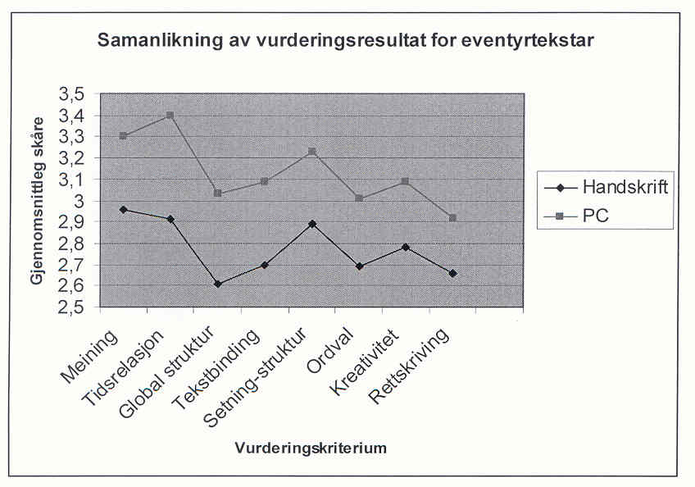
The children got in 2004 the same writing tests in grade 2 as the classes my project had in grade 3 in 2002. Also in grade 2 the PC classes wrote significant better texts at than the handwriting classes, now on all eight components: Meaning, time relation, global
structure, text binding, sentence structure, word variations, creativity and correct spelling. The differences was greatest at the fiction text: Compose a fairy tale (p<0.001 level).

Length of texts There was a strong correlation between
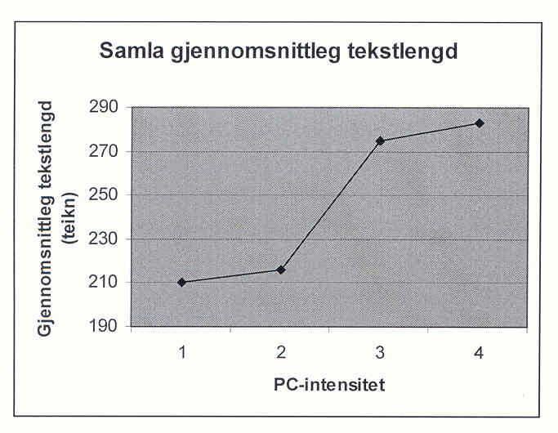
good quality of texts and text length.
1. Hand writing, no computers
2. Computer once a week in a computer lab
3. Computer some days in the week in class
4. Always access to computer writing in class
PC classes wrote longer texts. The handwriting classes wrote 210 signs (about 70 words) In classes where the children had max access to the computers all days in the classroom, the mean was 290 signs (nearly 100 words).
In the reading test however (Aasheim 2005), there was no difference between PC classes and hand writing classes. The problem is that the tests were dominated by decoding short words. This tests was in favour of classes using traditional phonic ABC books (Traavik 2002). While decoding tests have a long tradition and high degree of agreement among researchers, we have much less research about comprehension and comprehension tests, and more disagreement among researchers (Myrberg 2004:58). The National Reading tests in Norway 4. Grade 2004-2005 was criticised for weak validity for reading comprehension, and was withdrawn. New tests came in 2007, the validity is not evaluated yet.
Internationally meta-studies: Torgersen & Elbourne (2002) found students using computers more engaged, motivated, producing texts of greater lenghts and higher quality than handwriting students. Goldberg et al (2003) found that computer writing students in 26 studies 1990-2002 wrote longer, better, were more collaborating, social, motivated than “handwriting children”. A meta study of 12 writing projects after 1990 gave moderate better scores for computer writing at writing tests. (Kulik 2003).
Within Literacy research dominate Reading (90% of the hits at Google Scolar for instance). Writing have a tiny place. Hattie (2009) pp 130-142 report 52 meta-studies in Reading, only 5 in Writing. Most studies from grade 5 upwards. The biggest meta-study about writing is about adolescents (Graham and Perin 2007). They show high effects of planning, revising, editing, working together, clear goals, use of word processors.

Future research possibilities?
In this new praxis for “Writing to Read by Computer” I see possibilities for hundreds of different bachelor, master, doctoral, and post.doc studies within computer science, education, special education, psychology, linguistics, literature, anthropology, didactics in different school subjects etc.
Inspired of the author of this paper, the Department of Teacher Education, University of Helsinki, have started a discussion around a possible application for a comparative EU research project about Playful computer writing in Finland, Sweden, Norway, Estonia? Polen? Czeckia? Portugal? Other countries? For the three Nordic countries a questionnaire is already constructed for 300 teachers in the three countries who have been practicing playful computer writing in 1-5 years. Here the praxis field is so huge, so there are hundreds of possibilities for research. For the other countries it might be useful to start with one pioneer school to test the strategy, and follow the development in a three year period by master and doctor students.

Some rough ideas:
Will computer writing also in Grade 4-7 give better results than hand writing? Grade 8-12?
Development of emergent literacy in playful computer writing for 3-5 year olds?
Are the results specific for the first studies? For Norway? Replication in other countries?
Comparative studies: Differences in development Kurdistan-Sweden? Czeckia-Finland?
Effects for minorities in learning the majority language? Arabic->Norwegian, Russian/Estonian, Swedish/Finnish minority-versus Swedish majority in Åland and Sweden?
Russian versus Estonian schools in Estonia? Bilingual comparisons in other countries?
What are the conditions for implementation in a school, community, a whole country?
The touch writing system on PC: What effect on writing has the dominance of kinaesthetic/tactile senses? On different students, different learning styles?
Quite opposite handwriting will computer writing with both hands on the key board send the tactile/motor signals to both brain halves. What effect on the electronic patterns in the brain, thinking and language learning?
What is the effect of different keyboard training programs?
What effect in computer writing using Latin, Arab, Chinese, Japanese keyboard etc?
What are the effects of computer writing on ADHD children, deaf children, blind children, motor invalid children, socio-emotional problems …?
What are the effects on oral language in the pair discussion behind the computer?
Data linguistic analysis of thousands of electronic texts
What genre combinations, superstructure, inter texts, multimodal texts in the computer texts?
Multimodality. All texts are illustrated with drawings or paintings. Will the quality of drawings correspond with the quality of texts?
Will dramatizing of stories give better computer texts?
Will out door school and/or physical education give better computer texts?
What is the relations between rich libraries and the computer texts?
Dialect and sociolect variations in the written texts?
Invented spelling -> phonologic -> orthographic writing. What is the development in detail?
Longitudinal description of one child’s writing development 6-16 year

This is only examples of loose research ideas. The next 20 years I hope there will be hundreds of master- and doctor studies within this central, but almost non existent research area in Europe.
It was with great respect and humidity I presented “Writing to Read by Computer” in Erbil in Kurdistan, the oldest city of the world. The start of the Art of Writing and Mathematics were printing signs in clay in their Mesopotamian culture 6-8000 years ago, not handwriting. By printing texts by computers we go back to basic!

References
Alant, L. B et. al.(2003) Samhandling med, foran og via skjermen. (Collaboration with, behind and via the computer screen) ITU rapport nr 18 Oslo
Allard, B., & Sundblad, B. (1991). Skrivandets genes under skoltiden. (Development of writings during school). Stockholm: Stockholm university, Ped. institutionen.
Bangert-Drowns, R. L. (1993). The word processor as an instructional tool: A meta-analysis of word processing in writing instruction. Review of Educational Research, 63(1), 69-93.
Berge, K.L., & Vagle, W (2003). Utvikling og utprøving av nasjonale prøver i skriving [Developing national tests in writing]. Oslo: Universitetet i Oslo, Prosjektbeskrivelse.
Brostrøm, S (1995) 6-9 års pædagogik. Leg, leg, rammeleg (Play, play, frame play) Århus: Systime. Denmark
Chamless, J., & Chamless, M. (1993). The effects of instructional technology on academic achievement of 2nd grade students. Oxford: University of Mississippi.
Chomsky, C. (1982). Write now, read later. In C. Cazden (Ed.), Language in early childhood education (pp. 141–149) Washington, DC: National Association for the Education of Young Children.
Christie J & S. Stone (1999) Play in a Literacy-Enriched Play Center in Same-age and Multi-age Grouping Arrangement. TASP conference. New Mexico. USA
Christie, J & K. Roskos (2001) Research on play and literacy – a critical review. ICCP Conference Erfurt. Ger.
Clay M (1975) What did I write? Beginning writing behaviour. Heinemann. New Zealand
Cropley,A.J.(1967) Creativity. Longmans, Green & Co. Ltd
DEE. (1997). The implementation of the National Literacy Strategy. London: Dep. for Education and Skills.
Eisner, E. (1994). Cognition and curriculum reconsidered (2nd Ed.). N. York: Teachers College Press.
Erstad, O. (1998). Innovasjon eller tradisjon [Innovation and tradition]. Oslo: Univ. i Oslo, ITU.
Erstad, O. (2005) Digital kompetanse i skolen. Oslo: Universitetsforlaget
Ervik, A. B. (2004) Play as a basis for stimulating literacy and language in upper primary school in Norway. Paper ICCP Krakow. Poland
Folkesson, A.M (2005) Datorn i det dialogiska klassrummet. Studentlitteratur AB
Goldberg et al (2003) The Effect of Computers on Student Writing: A Meta-analysis of Studies from 1992-2002 The Journal of Technology, Learning and Assessment 2 (1): 2-51
Gorman, T.P., Purves, A.C., & Degenhart, R.E. (1988). IEA Volume 5. New York: Pergamon Press.
Graham, S & Perin, D. (2007). A meta-analysis of writing instructiuon for adolescent students. Journal of Educational Psychology, 99(3), 445-476.
Grimsø, I. (2003) Du bare legger fingrene sånn. Hovedfag pedagogikk Høgskolen i Oslo
Guilford, J.P (1950 Creativity. American Psycologist 5, 444-54
Hagtvet, B. (1988) Skriftspråksutvikling gjennom lek. (Literacy through play) Universitetsforlaget. Oslo
Hall, N. & L. Abott (eds) (1991) Play in the Primary Curriculum. Hodder & Stoughton. London
Hargreaves, A. and Shirley, D. (2009). The Fourth Way: The inspiring future of educational
change. Thousand Oaks: Corwin.
Hartmann W (1988) Spiel und elementares Lernen. Österreichischer Bundesverlag. Wien
Hattie, J. (2009). Visible learning. A synthesis of over 800 meta-analyses relating to achievement. Routlegde. London and New York
Healy, J.M. (1998). Failure to connect: How computers affect our children’s minds—for better and worse. New York: Simon & Schuster.
Helleve, I. (2001) Samspel med data? (Collaboration behind the computer) Hovudfag i pedagogikk. Bergen
Hoel, T. Løkensgard. (2000). Skrive og samtale. Responsgrupper som læringsfellesskap [Writing and
conversation: Response groups as learning community]. Gyldendal, Norway: Akademisk.
Huizinga,J. (1955) Homo Ludens. A study of the play element in culture. London/Boston: Beacon Press
Høien, T. (1996). Avkodingsstrategier og leseutvikling[Decoding strategies and reading development]. In Austad (red) Mening i tekst. LNU/Cappelen Akademisk.
ITU Monitor (2007) University of Oslo
Karlsdottir, R. (1998). Utvikling av lese- og rettskrivingsferdigheter hos grunnskolebarn i Trondheimsområdet. (Development of reading and spelling skills by school children in Trondheim area) I Learning strategies and skill learning. Skrift 4 s 93-109. Det kgl. norske videnskabers selskab. Trondheim.Tapir.
Keetley, E. (1997). Comparison of first grade computer assisted and handwritten process story writing. Master’s dissertation, Johnson and Wales University. (ERIC Document Reproduction Services No. ED384882)
Koschmann, T. (Ed.). (2001). CSCL: Theory and practice of an emerging paradigm. Mahwah, NJ:Erlbaum.
Kress, G (1997) Before writing. www.amazon.co.uk
Kress, G (2003) Literacy in the New Media Age. NY.Routledge
Kulik, J.A. (2003) Effects of Using Instructional Technology in Elementary and Secondary School. SRI International. Project number P10446.001
L 97 Læreplanverket for den 10 -årige grunnskolen (The National Curriculum 1997) KUF.
L 2006 Læreplan for grunnskolen og videregående opplæring (The National Curriculum 2006)
www.odin.dep.no/filarkiv/255552/lplan
Lang, A. (2002) Creative writing on computers in lower primary school. Tallina Pedagoogikaülikooli Täienduskoolituse osakond
Lave, J., & Wenger, E. (1991). Situated learning: Legitimate peripheral participation. New York:
Cambridge University Press.
Liang, P., & Johnson, J. (1999). Using technology to enhance early literacy through play. Computers in the Schools, 15(1), 55–64.
Lillemyr O F (2003) Play in School – The Teacher’s Role. Reforms and Recent Research. In Saracho & Spodek (red) Contemporary Perspectives of Play in Early Childhood Education. Greenwich. Connecticut: Information Age Publishing Inc.
Lindquist, G (1995) The Aestetics of Play. Doctoral dissertation. Uppsala University. Sweden
Lorentzen, R. T. (1999)Barns skriftspråksutvikling. Moslet, I. red. Norskdidaktikk-ei grunnbok s 94-109.Tano A
Ludvigsen, S. (1999). Informasjons- og kommunikasjonsteknologi, læring og klasserommet.
[Information and communication technology, learning and the classroom]. Bedre skole, 2.
Moyles, J (1994) The Excellence of Play. Open University Press. Buckimham
Myrberg, M.(2004) Att förebygga och möta läs- och skrivsvårigheter.En forskningsöversikt. Skolverket. St. holm
Onarheim, E.N.B. (2006) Møte med tekst (Meeting with texts) Master thesis Pedagogic. University of Bergen
Pessanha, A (1995) Comparative Study of Play ICCP/TASP conference Salzburg
Piaget, J. (2001) The psychology of intelligence (M. Piercy & D.E. Berlyne, Trans.). London: Routledge.
Pramling I (2007) Can Play and Learning be integrated in an goalorientated preschool? NERA Turku, Finland
Purves, A.C. (Ed.). (1992). The IEA study of written composition II: Education and performance in fourteen countries. Oxford: Pergamon Press.
Retter, H (1983) Spielen – Arbeiten – Lernen. Spielmittel nr. 5 Germany
Salomon, G., et al. (2004). Computers and writing. In T. Nunes & P. Bryant (Eds.), Handbook of children’s literacy (pp. 409–442). Boston: Kluwer.
Schrader, C.T. (1990). The word processor as a tool for developing young writers (Journal Code
RIEDEC1990). (ERIC Document Reproduction Service No. ED321276)
Singh, B. (1993). IBM’s Writing to Read program: The right stuff or just high tech fluff? ERIC No. ED339015
Sulzby, E. (1989). Assessment of writing and of children’s language while writing. In L. Morrow & J.
Smith (Eds.) The role of assessment and measurement in early literacy instruction (pp. 83–109).
Englewood Cliffs, NJ: Prentice-Hall.
Sutton-Smith, B. (1990) Dilemmas in adult play with children. ICCP conference Germany
Sutton-Smith, B. (1997) The Ambiguity of Play. Cambridge. Massachusetts
Søby, M. m.fl. (2005) ITU monitor. www.itu.no/itu_monitor
Torgerson, C. J. & Elbourne, D. (2002). A systematic review and meta-analysisof the effectiveness of ICT on the teaching of spelling. Journal of Research in Reading, 25(2), 129-143.
Trageton,A.(1995) Lek med materialer 1-7 år (Play with materials) pp 19-20. Høgskolen Stord/Haugesund
Trageton, A. (1997) Leik i småskolen. (Play in lower primary school) Fagbokforlaget
Trageton, A. (2001). Creative writing on computers:Playful learning, Grade 1. Erfurt, Germany: ICCP.
Trageton, A. (2002). Creative writing on computers: Playful learning, Grade 2. TASP. Santa Fe, New.Mexico
Trageton, A. (2003a). Creative writing on computers: Playful learning, Grade 3, End results. Copenh.: NFPF.
Trageton, A. (2003b). Å skrive seg til lesing. IKT i småskolen [Writing to read: ICT in lower Primary School]. Oslo. Universitetsforlaget.
Trageton, A. (2004) At skrive sig til läsning. Gyldendal. Danish version
Trageton, A. (2005) Att skriva sig till läsning. Liber. Swedish version
Trageton ,A.(2007) Luukeman oppiminen kirjoittamalla. PS. Jyväskylä. Finnish version
Trageton, A. (2005a) Play in Lower Primary School in Norway. In Lytle, Mc Mahon, Sutton-Smith:
Play & culture studies vol 6 pp 157-179 Lanham, Maryland : Univ.Press of America
Trageton, A. (2005b) Creative writing on computers: 6- to 10-year olds. Writing to Read. In Pandis, M et al: Reading, Writing , Thinking. Proceedings of the 13th European Conference on Reading pp 170-177. International Reading Association. Newark. DE. USA
Trageton, A. (2005c) Skriv på PC – lær å lese (Write on computer – learn to read) PEDLEX. Oslo
Trageton, A. (2010) Skriv på PC- lær å lese. 2. utgave (Write on computer – learn to read) PEDLEX. Oslo
Traavik, H. (2002) Nye ABC-er. Mye å velge mellom. Utdanning nr 29/30 s 60-61
Vavik, L. (2003). Writing to read with ICT support. Research description. Stord/Haugesund University College
Vavik, L (2009) Light and Shadows in the Instructional Use of ICT. The Norwegian Stord Studies Stord/Haugesund University College. EARLY. Brussel
Vygotsky, L.S. (1978). Mind in society: The development of higher psychological processes . M. Cole, V. John-Steiner, S. Scribner, & E. Souberman, Eds. & Trans.). Cambridge, MA: Harvard University Press
Wassermann S (2000). Serious players in the primary classroom 2nd ed. NY. Teachers College Press
Willows, D.M. (1988). Writing to read as a new approach to beginning language arts instruction.
Toronto, ON: University of Toronto, Ontario Institute for Studies in Education.
Wössmann, L & Fuchs,T (2004) Computer and Student Learning: Bivariate and Multivariate Evidence on the Availability and Use of Computers at Home and at School. Economic papers no 190 (Commission of the European Communities) Brussel EC

Ei komparativ studie av tradisjonell lese- og skriveopplæring og pc-støtta skrive- og leselæring. Masteroppgåver. IKT i læring. Stord/Haugesund University College
(Studies of traditional reading- and writing teaching and computer-based writing- and reading learning.
Master thesis ICT in learning)
Aasheim N. J. (2005) Lesedugleik. (Reading level) Stord/Haugesund University College
Paulsen E. S.(2005) Skrivedugleik. (Writing level) Stord/Haugesund University College
Sandal A. K. (2005) Lærarhaldningar. (Teacher attitudes) Stord/Haugesund University College

