ICCP conference 2010

Lisboa June 16-18

Portugal

Writing to Read.
Playful computer writing. Grade 1. - 4. 1999-2002.
Innovations 2002-2010

Reading research dominate over Writing research. Within Writing research, Computer writing is seldom.
The pioneer project in four Nordic countries was earlier presented in ICCP Krakow 2004. In that paper I documented that playful computer writing for 6-9 years olds gave much better writing results than traditional handwriting classes. Surprisingly, delaying handwriting to grade 3, gave also better quality in computer classes.
This paper describe the mass innovations, implementations, school development and action research 2002-2010 in the Nordic countries. This strategy is a radical turn in literacy learning from the traditional Reading and Writing to Writing to Read in a playful, expressive and creative way.
The strategy fit well to the Nordic Curriculums, where children are seen as knowledge producers, within a socio-cultural paradigm.
The Norwegian textbook for teachers is translated to Danish, Swedish and Finnish. The strategy have now spread to hundreds of schools in Norway, Denmark, Sweden and Finland. Courses for 20 000 teachers.
Because there is almost no Nordic research in this area, it is important that 50-60 bachelor degrees of teacher students in Sweden are produced. Perhaps similar in the other countries. 20-25 master degrees explore different sides within the field, and document similar positive effect as the pioneer study. However, only 2 doctoral studies, and 2 post-doctoral project have started yet.
The University of Helsinki in Finland discuss an application for an EU research project in 6-7 countries to compare the effect of this strategy in different cultures.
May Portugal and other countries be interested?

Key words: literacy, computer, writing, play, creativity, 6-9 year

Associate professor
Arne Trageton
e-mail: arne.trageton@hsh.no
Stord/Haugesund University College (retired)
5414 Stord,
Norway

The Pioneer project 1999-2002 Short resume
First a short resume of the pioneer project (Trageton 2004a, 2005b) Problem:
Will playful computer writing (6-9 years), and delayed formal teaching of handwriting to grade 3 give better writing results, easier and more joyful reading?
The Norwegian school have in 160 years been teaching Reading- and writing. But Writing is easier than reading for 4-7 year olds (ex. Clay 1975, Chomsky 1982, Sulzby 1989, Hall 1987, Hagtvet 1988, Liberg 1993). Writing to Read is the natural way. But handwriting is difficult for 5 – 7 year olds. The easier computer writing solved the problem. Computer research in school/preschool is very common, but few study computer writing for 5-9 year olds. Almost none combine such studies with play and creativity research. Teachers and children in my project used a more playful, creative, informal approach than the huge American Writing to Read (Chamless & Chamless 1993)
Through action development and research in 14 classes in Norway, Denmark, Finland and Estonia 1999-2002, the 6 year olds easily learned both Writing and Reading through play. Traditional textbooks in grade 2 became unnecessary, but school library was important. They produced their own textbooks by playing “Authors”, “Publishing house” and “Newspaper office”. In grade 3 they composed more complicated books in different genres and advanced newspapers. The writing stimulated intensive and joyful reading. Development is documented by 7500 multimodal texts (drawing and verbal text) and 60 edited videos.
Table 1. Factual and fiction writing
 | Dentist visit |  |  | Fairy tale
 | Boys | Girls | Total | Boys | Girls | Total
Computer classes | 2.16 | 2.54 | 2.33 | 2.27 | 2.43 | 2.32
Handwriting classes | 1.78 | 2.28 | 2.05 | 1.85 | 2.24 | 2.05
In the tests after three years, the computer classes showed higher quality in composing factual prose and fairy tale than handwriting classes, significant on p>0.001 level. Simplified: The mean in computer classes was one year ahead of the handwriting classes.
Surprisingly, also the handwriting tests showed significant higher quality in the PC classes on p>0.001 level, in spite of the delayed handwriting and much shorter exercise time. The results may lead to radical changes in literacy learning for 6-9 year olds. www.hsh.no/home/atr/tekstskaping
The mass implementation 2002-2010
How to spread the playful “Writing to Read” strategy in the Nordic countries?
The strategy behind the project was action research, action learning and school development (Tiller 1999). This is also the key strategy for the mass implementation. Because of the good results of this project, many communities in the Nordic countries wanted to implement and improve this literacy strategy for grades 1.– 4. (6-9 year olds)
Consumer ideology
Some politicians have a naïve belief that more computers give more learning. They have spent billions of euros for computers and software. But PISA show: More computers - less learning (Wössmann & Fuchs 2004). Computers are often misused in a consumer ideology based on old behaviourism, heavily sponsored by the computer industries. The old software programs follow the traditional stimulus – response model. The program control the child, like the traditional teacher in asking yes- no questions. A meta study of 300 computer research reports gave little, none or negative learning effect (Healy 1998). She report serious damages to children’s concentration and learning from using program packs within a behaviouristic consumer ideology. Jonassen (2000) found that 85 % of “pedagogic software programmes” in school were of this behaviouristic consumer type, harmful for learning.

Producer ideology
Quite opposite, the Norwegian National Curriculum from 2006 regards the student as producer and communicator of his own knowledge. This is related to a playful, creative mode. The fundament is 5 key competencies in all subjects: Orally expression. Written expression. Reading. Mathematics and the new Digital competence (produce, compose and publish own multimodal texts). The expression and production comes first (not reading)! The digital competence will also strengthen the writing side of literacy.
All the Nordic National Curriculums follow a constructivist and socio-cultural view of learning (Lave & Wenger 1991, Piaget 2001, Vygotsky 1978) and computer-supported collaborative learning paradigm (CSCL) in computer research (Koschmann, 2001). Expressing yourself oral and written on computer is obligatory in grade 1 & 2 both in Norway and Finland. My strategy fit therefore very well with all Nordic National Curriculums.
Similar, EU proclaim 2006 eight key competences:
1. Communication - mother tongue
2. Communication - foreign languages
3. Math/science/technology
4. Digital competence
5. Learning to learn
6. Intercultural/social/civic
7. Entrepreneurship
8. Cultural expression
1.Communication start with expressing yourself oral and written. Freedom of speech is central in democracy . In 4. Digital competence the student should produce, compose, present and exchange communication. My strategy also stimulate Communication-foreign language, Learning to learn, Intercultural/social/civic, Entrepreneurship and Cultural expression.
Besides Piaget and Vygotskys play theories, play as culture production is a fundament (Huizinga 1955, Gadamer 1965, Sutton-Smith 1990). The Play and Literacy research in US (Christie & Roskos 2001) and the relation play-literacy-computers (Liang & Johnson 1999) give valuable theoretical/practical background and inspiration. Pessanha & Sousa (2007) also advocate an active adult role in literacy play in Portugal.
Creativity processes like divergent thinking, idea richness, flexibility, originality, fluency, flow, openness, intuition, experimenting, problem solving, entrepreneurship, playful, humorous, artistic thinking, (Cropley 1967) fit together with play. After 2000 there have been a strong criticism of the one-sided convergent IEA test types, with right/wrong answers. New creativity research (Csikszentmihalyi, M. 1996, 2000) give arguments for more playful learning, social/cultural/ aesthetic processes and knowledge production in the curriculum (Creative Partnerships, 2005b, para.2) Countries with high standard in culture/art subjects, also scored high on the PISA tests, for instance Finland. (Bamford 2006). English Ofsted report that creative approach raise standards http://www.ofsted.gov.uk/Ofsted-home/Publications-and-research/Browse-all-by/Documents-by-type/Thematic-reports/Learning-creative-approaches-that-raise-standards Creative processes is necessary for educational change in school development (Hargreaves and Shirley 2009)
Text production by computers became richer, longer, more varied, with higher reflection and arguing level, more collaboration and feedback than handwriting at grade 1-12. Erstad (2005) The creative expression and production is central. The most used tool for that in school is the computer writing function, also in grade 9! (Vavik 2009). Computer writing dominate in public life. Also in the private life outside school playful, creative computer writing dominate in most age groups through e-mail, SMS, chat, blogs, face book etc.

Textbooks, videos, website
Learning materials for teachers are important. The pioneer project gave background for writing a textbook for teacher education (Trageton 2003b). Adjusted versions are translated to Danish 2004, Swedish 2005 and Finnish 2007. Good contacts with parents is were very important. They were strong supporters for modernising the school. Therefore I also made a book for parents, administrators and politicians about the essentials in the playful computer strategy in Writing to Read. (Trageton 2005c). The second reprint of this book also have a chapter about play with letters and words on computers in preschool (Trageton 2010). To study literacy play on computers 1-5 years is a demanding research project for the future. Here we have only developed some practical examples yet.
60 videos were produced in the pioneer project, 18 of them are re-edited and published at 3 DVD discs, showing different classes in action in computer writing in grade 1 - 3 (post@av-senteret.no) . The videos are effective materials for students and teachers for implementation of this writing/reading strategy in own class.
The website www.hsh.no/home/atr/tekstskaping consist of video examples from all countries in the project, (some also English text), TV news in Norway, Denmark, Sweden, articles in Norwegian and English, reports from newspapers/magazines from the Nordic countries. A representative database of 1000 chosen texts from grade 1- 3 shows the development of computer writing.

Courses
The most effective strategy for implementation and creative school development is to combine pressure from top and bottom. The town Bergen (200 000 inhabitants) is a good example. The ICT counsellor for the town sent a letter to the principals for all 65 primary schools in Bergen and invited schools to start. The principals talked with their teachers in grade 1 to find out if they were interested. 18 schools wanted to start in 2002. The teachers got a day course in June; the principal had the responsibility for installing 4 recycled computers and a printer in every classroom. In a follow up course in October, the teachers presented their experiences in the start period for each others for inspiration and debate. A third course was held after a year to exchange experiences and discussing consequences for the next year in grade 2. Next year 42 schools wanted the same strategy, and in 2005 this strategy became obligatory for all 65 schools in Bergen. Many smaller towns and communities followed the example of Bergen. In Sweden I have had courses for about 14000 teachers and students. Hundreds of schools have started. Many communities use the Bergen model for implementation in most schools in the community. A national ICT network for teachers working with Playful computer writing is organized. In Finland about 150 teachers have tried this strategy for 1-3 years. In Espoo 25 schools have started, also using the Bergen model. Åland have also used the same model for 85% of the schools.

Multicultural schools
In Oslo perhaps 20% of the students are multicultural. Vahl school had 92% multicultural students. After a course they let the children learn Writing to Read on their mother tongue on computers, before translating to Norwegian. From grade 2 they are producing textbooks in two languages: Arabic->Norwegian, Urdu->Norwegian, Turkish-> Norwegian and Somali->Norwegian. The best of these textbooks are published for sale.
The following example is the first draft for a page who hopefully later will be a interesting Arabic-Norwegian textbook about the environment around the school.

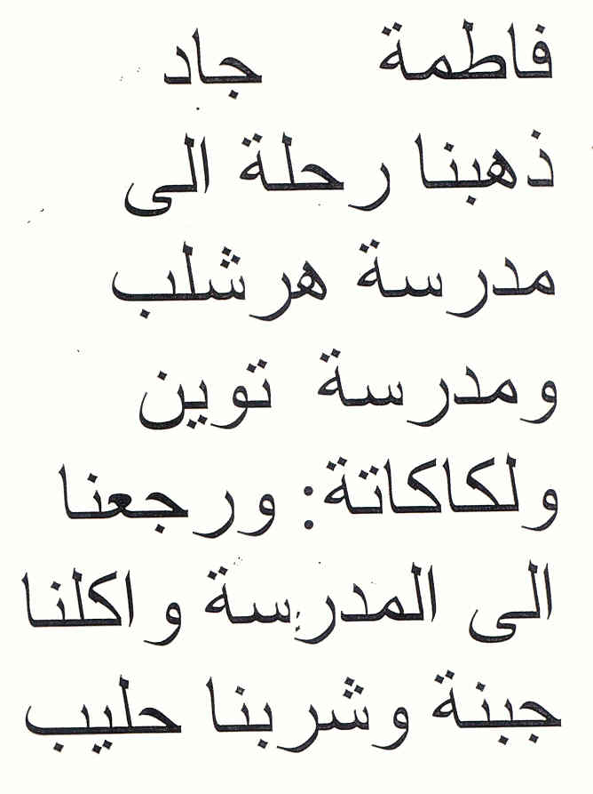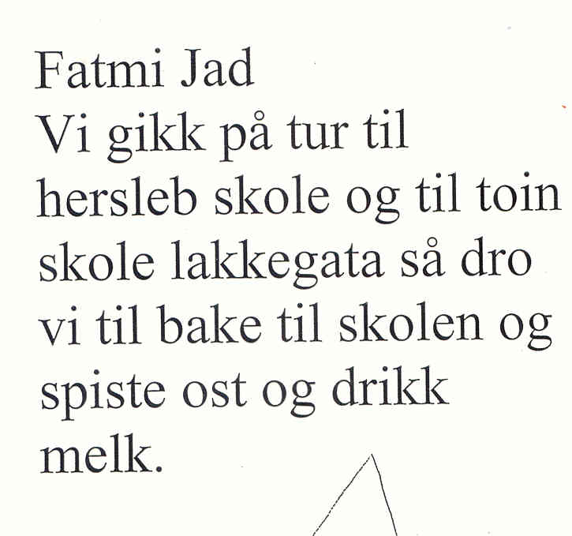
Fatmi & Jad
We went a trip to Hersleb school and to Tøyen school and Lakkegata. Then we went back to our school and ate cheese sandwiches and drank milk.

The mother can read the Arabic version, and the child can be teacher for her mother in learning Norwegian! This may knit the family and school better together. Many multilingual schools in Sweden have followed the Norwegian example. After a course in Örebro in Sweden, a mother tongue teacher in Kurdish started this strategy in teaching the immigrant children Kurdish->Swedish. She contacted the minister of Education in the Kurdistan Region in Northern Iraq. We became invited for a week, where we held 3 courses for 500 teachers and students at the University. The Minister started in 2006 a similar project with 4 schools in Kurdistan. For them Kurdish -> English learning was very interesting. In bilingual Finland the strategy is interesting in Swedish->Finnish and Finnish->Swedish learning. I had also a course for 23 Russian immersion schools in Estonia, where the Russian children should only use Estonian language the first 4 years at school. The playful computer writing is effective to learn the new language. On my website there are several videos from bilingual computer writing. Perhaps some other countries might be interested to use this strategy in bilingual learning? What about research?

New research
Will new research confirm, widen, adjust or contradict the pioneer results?
I like the creative OECD definition: Research is a combination of pure research, applied research, innovation and implementation. Action research and learning start at the bottom, with innovations to change praxis. Teachers and students make small reports on a lower level, perhaps a hundred bachelor thesis are produced up to now.
Research about computer writing for 5-9 year olds is seldom also in the other Nordic countries. An exception is Folkesson (2005) in Sweden, evaluating computer writing 6-9 year olds in one class, with similar findings as in my project. It is therefore important that the new innovations in the Nordic countries are followed up with research. Åbo akademi, Vasa in Finland made 2006-2009 a similar innovation/research project Intelligent på tangent led of professor Yllikallio (2009) http://www.vasa.abo.fi/vos/lag/projects/inteltang/riasruta.htm The first bachelor- and master degrees are published. Inspired of my courses in Vasa and Helsinki University, there is now a lot of innovations in Finland. In the 25 Espoo schools several students now make their master thesis. The Finnish teachers on my postgraduate courses at Helsinki University have already master degrees. The most experienced have now 1-3 year experience with playful computer writing with many possible doctoral studies. Two post doctor projects at Helsinki University have started.
Besides my project, there are only a few studies in Norway. Alant et.al (2003) found higher level on texts written on computers in grade 3, more motivation and collaboration. Helleve (2001) studied the discussions among the pairs behind each computer about what to write. She found that the oral language got a very advanced level when the students succeeded in cooperating around common texts. Grimsø (2003) followed her own class for 3 year and made a qualitative analysis of the development. Onarheim (2006) studied the interaction student-student-teacher around the texts. 5 master degrees in “ICT in learning” at Stord/ Haugesund University College, 4 evaluating the development in Bergen.(Salomon et al. 2004, Vavik 2003, Aasheim 2005, Paulsen 2005, Sandal 2005, Sørensen 2005). Here follow a bit of the master thesis about writing tests in grade 2 (Paulsen 2005). The texts were scored of three independent evaluators. 4 is top level, 3 over middle, 2 below middle, and 1 is bottom level.

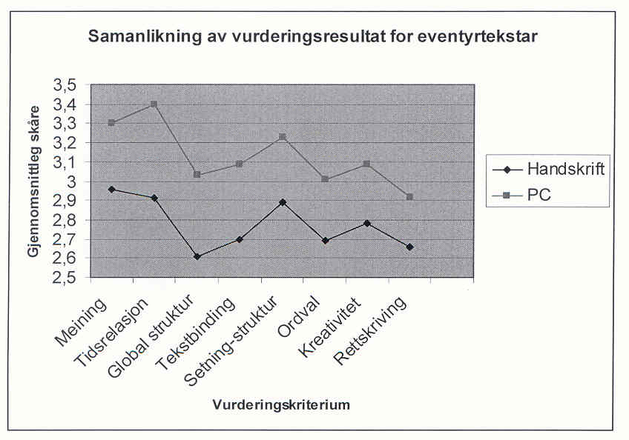
Table 2. Fairy tale. Comparison PC classes – Handwriting classes

The children got in 2004 the same writing tests in grade 2 as the classes my project had in grade 3 in 2002. Also in grade 2 the PC classes wrote significant better texts at than the handwriting classes, now on all eight components: Meaning, time relation, global
structure, text binding, sentence structure, word variations, creativity and correct spelling. The differences was greatest at the fiction text: Compose a fairy tale (p<0.001 level).

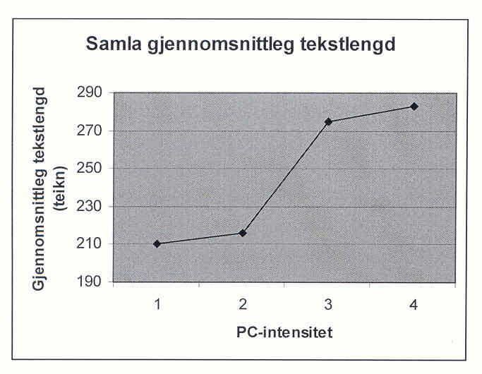
Table 3. Length of texts

There was a strong correlation between good quality of texts and text length.
1. Hand writing, no computers
2. Computer once a week in a computer lab
3. Computer some days in the week in classroom
4. Always access to computer writing in classroom
PC classes wrote longer texts. The handwriting classes wrote 210 signs (about 70 words) In classes where the children had max access to the computers all days in the classroom, the mean was 290 signs (nearly 100 words).
In the reading test however (Aasheim 2005), there was no difference between PC classes and hand writing classes. The problem is that the tests were dominated by decoding short words. This tests was in favour of classes using traditional phonic ABC books (Traavik 2002). While decoding tests have a long tradition and high degree of agreement among researchers, we have much less research about comprehension and comprehension tests, and more disagreement among researchers (Myrberg 2004:58). The National Reading tests in Norway 4. Grade 2004-2005 was criticised for weak validity for reading comprehension, and was withdrawn. New tests came in 2007, the validity is not evaluated yet.
Through meta studies in USA Goldberg (2003) found that in 26 writing studies “computer children” wrote longer, better, were more collaborating, social, motivated than “handwriting children”. Kulik (2003) reported that computer writing in 12 studies showed better score at writing tests. But still Writing have only 10% of the literacy studies versus Reading 90% (Hattie 2009), and studies of computer writing is very seldom.

Future research possibilities?
In this new praxis for “Writing to Read by Computer” I see possibilities for hundreds of different bachelor, master, doctoral, and post.doc studies within computer science, education, special education, psychology, linguistics, literature, anthropology, didactics in different school subjects etc.
Inspired of the author of this paper, the Department of Teacher Education, University of Helsinki, have started a discussion around a possible application for a comparative EU research project about Playful computer writing in Finland, Sweden, Norway, Estonia? Poland? Czeckia? Portugal? Other countries? For the three Nordic countries a questionnaire is under construction for 300 teachers who have been practicing playful computer writing in 1-5 years. Here the praxis field is huge, with hundreds of different possibilities for research. For other countries it might be useful to start with one pioneer school to test the strategy, and follow the development in three year by master and doctor students.
Some rough research ideas:
Will computer writing also in Grade 4-7 give better results than hand writing? Grade 8-12?
Emergent literacy in playful computer writing for 3-5 year olds
Are the results specific for the first studies? Replication other countries?
Comparative studies: Culture differences Kurdistan-Sweden? Estonia-Finland? Portugal-Czeckia?
Bilingual learning Arab->Norwegian, Russian->Estonian, Swedish/Finnish minority-versus Swedish majority in Åland and Sweden? Portugese->English Bilingual comparisons in other countries?
What are the conditions for implementation in a school, community, a whole country?
Will role play and construction play give better computer texts?
Will dramatizing of stories give better texts?
Will out door school and/or physical education give better computer texts?
The touch writing system on PC: What effect on writing has the dominance of kinaesthetic/tactile senses?
Quite opposite handwriting will computer writing with both hands send the tactile/motor signals to both brain halves. What effect on the electronic patterns in the brain, thinking and language learning?
What is the effect of different keyboard training programs? Effect of Latin, Arab, Chinese, Japanese keyboard ?
What are the effects of computer writing on ADHD children, deaf children, blind children, motor invalid children, socio-emotional problems …?
The effects on oral language in the pair discussion behind the computer?
Data linguistic analysis of thousands of electronic texts
What genre combinations, superstructure, inter texts, multimodal texts in the computer texts?
Multimodality. Drawings + paintings. Will the quality of drawings correspond with the quality of texts?
What is the relation between a rich literacy environment and library and the computer texts?
Dialect and sociolect variations in the written texts?
Invented spelling->phonologic-> orthographic writing. What is the development in detail?
Longitudinal description of one child’s writing development 6-16 year
This is only examples of loose research ideas. The next 20 years I hope there will be hundreds of master- and doctor studies within this central, but almost non existent research area. In a playful way the children will get more fun in better literacy learning.
It was with great respect and humidity I presented “Writing to Read by Computer” in Erbil in Kurdistan, the oldest city of the world. The Art of Writing started with printing signs in clay in their Mesopotamian culture 6-8000 years ago, not handwriting. By printing texts on computers we go back to basic!

References
Alant, L. B et. al.(2003) Samhandling med, foran og via skjermen. (Collaboration with, behind and via the computer screen) ITU rapport nr 18 Oslo
Allard, B., & Sundblad, B. (1991). Skrivandets genes under skoltiden. (Development of writings during school). Stockholm: Stockholm university, Ped. institutionen.
Berge, K.L., & Vagle, W (2003). Utvikling og utprøving av nasjonale prøver i skriving [Developing national tests in writing]. Oslo: Universitetet i Oslo, Prosjektbeskrivelse.
Chamless, J., & Chamless, M. (1993). The effects of instructional technology on academic achievement of 2nd grade students. Oxford: University of Mississippi.
Chomsky, C. (1982). Write now, read later. In C. Cazden (Ed.), Language in early childhood education (pp. 141–149) Washington, DC: National Association for the Education of Young Children.
Christie J & S. Stone (1999) Play in a Literacy-Enriched Play Center in Same-age and Multi-age Grouping Arrangement. TASP conference. New Mexico. USA
Christie, J & K. Roskos (2001) Research on play and literacy – a critical review. ICCP World Play Conference Erfurt. Germany
Clay, M (1975) What did I write? Beginning writing behaviour. Heinemann. New Zealand
Cropley,A.J.(1967) Creativity. Longmans, Green & Co. Ltd
Eisner, E. (1994). Cognition and curriculum reconsidered (2nd Ed.). N. York: Teachers College Press.
Erstad, O. (2005) Digital kompetanse i skolen. Oslo: Universitetsforlaget
Folkesson, A.M (2005) Datorn i det dialogiska klassrummet. Studentlitteratur AB
Gadamer (1965) Wahrheit und Methode. JBC Mohr. Tübringen
Goldberg et al (2003) The Effect of Computers on Student Writing: A Meta-analysis of Studies from 1992-2002 The Journal of Technology, Learning and Assessment 2 (1): 2-51
Gorman, T.P. Purves, A.C., & Degenhart, R.E. (1988). IEA Volume 5. New York: Pergamon Press.
Grimsø, I. (2003) Du bare legger fingrene sånn. Hovedfag pedagogikk Høgskolen i Oslo
Guilford, J.P (1950) Creativity. American Psycologist 5, 444-54
Hagtvet, B. (1988) Skriftspråksutvikling gjennom lek. (Literacy through play) Universitetsforlaget. Oslo
Hall, N. (1987) The emergency of literacy. Portsmouth, NH: Heinemann
Hargreaves, A. and Shirley, D. (2009). The Fourth Way: The inspiring future of educational
change. Thousand Oaks: Corwin.
Hartmann W (1988) Spiel und elementares Lernen. Österreichischer Bundesverlag. Wien
Hattie, J. (2009) Visible learning. A synthesis of over 800 meta-analyses relating to achievement. Routledge
Healy, J.M. (1998). Failure to connect: How computers affect our children’s minds—for better and worse. New York: Simon & Schuster.
Helleve, I. (2001) Samspel med data? (Collaboration behind the computer) Hovudfag i pedagogikk. Bergen
Hoel, T. Løkensgard. (2000). Skrive og samtale. Responsgrupper som læringsfellesskap [Writing and
conversation: Response groups as learning community]. Gyldendal, Norway: Akademisk.
Huizinga,J. (1955) Homo Ludens. A study of the play element in culture. London/Boston: Beacon Press
Høien, T. (1996). Avkodingsstrategier og leseutvikling[Decoding strategies and reading development]. In Austad (red) Mening i tekst. LNU/Cappelen Akademisk.
Jonassen,D.H. (2000-2004) Computers as mindtools for schools. Pearson, or Amazon. com
Keetley, E. (1997). Comparison of first grade computer assisted and handwritten process story writing. Master’s dissertation, Wales University. (ERIC Document Reproduction Services No. ED384882)
Koschmann, T. (Ed.). (2001). CSCL: Theory and practice of an emerging paradigm. Mahwah, NJ:Erlbaum.
Kress, G (1997) Before writing. www.amazon.co.uk
Kress, G (2003) Literacy in the New Media Age. NY.Routledge
Kulik, J.A. (2003) Effects of Using Instructional Technology in Elementary and Secondary School. SRI International. Project number P10446.001
L 97 Læreplanverket for den 10 -årige grunnskolen (The National Curriculum 1997) KUF.
L 2006 Læreplan for grunnskolen og videregående opplæring (The National Curriculum 2006)
www.odin.dep.no/filarkiv/255552/lplan
Lang, A. (2002) Creative writing on computers in lower primary school. Tallina Pedagoogikaülikooli Täienduskoolituse osakond
Lave, J., & Wenger, E. (1991). Situated learning: Legitimate peripheral participation. New York:
Cambridge University Press.
Liang, P., & Johnson, J. (1999). Using technology to enhance early literacy through play. Computers in the Schools, 15(1), 55–64.
Liberg, C (1993) Hur barn lär sig läsa och skriva.( How children learn to read and write) Studentlitteratur. Sw
Lillemyr O F (2003) Play in School – The Teacher’s Role. Reforms and Recent Research. In Saracho & Spodek (red) Contemporary Perspectives of Play in Early Childhood Education. Greenwich. Connecticut: Information Age Publishing Inc.
Lindquist, G (1995) The Aestetics of Play. Doctoral dissertation. Uppsala University. Sweden
Ludvigsen, S. (1999). Informasjons- og kommunikasjonsteknologi, læring og klasserommet.
[Information and communication technology, learning and the classroom]. Bedre skole, 2.
Myrberg, M.(2004) Att förebygga och möta läs- och skrivsvårigheter.En forskningsöversikt. Skolverket. St. holm
Onarheim, E.N.B. (2006) Møte med tekst (Meeting with texts) Master thesis Pedagogic. University of Bergen
Pessanha, A & de Sousa M.B (2007) Play and literacy ICCP conference Brno, Czeckia
Piaget, J. (2001) The psychology of intelligence (M. Piercy & D.E. Berlyne, Trans.). London: Routledge.
Pramling I (2007) Can Play and Learning be integrated in an goalorientated preschool? NERA Turku, Finland
Purves, A.C. (Ed.). (1992). The IEA study of written composition II: Education and performance in fourteen countries. Oxford: Pergamon Press.
Salomon, G., et al. (2004). Computers and writing. In T. Nunes & P. Bryant (Eds.), Handbook of children’s literacy (pp. 409–442). Boston: Kluwer.
Schrader, C.T. (1990). The word processor as a tool for developing young writers (Journal Code RIEDEC1990) (ERIC Document Reproduction Service No. ED321276)
Sulzby, E. (1989). Assessment of writing and of children’s language while writing. In Morrow & Smith (eds) Assessment for instruction in early literacy. (pp. 83-109) Englewood Cliffs
Sutton-Smith (1990)Dilemmas in adult play with children. ICCP. conference Germany
Sutton-Smith, B. (1990) Dilemmas in adult play with children. ICCP conference Germany
Sutton-Smith, B. (1997) The Ambiguity of Play. Cambridge. Massachusetts
Søby, M. m.fl. (2007) ITU monitor. www.itu.no/itu_monitor
Trageton,A.(1995) Lek med materialer 1-7 år (Play with materials pp 19-20. Høgskolen Stord/Haugesund
Trageton, A. (1997) Leik i småskolen. (Play in lower primary school) Fagbokforlaget
Trageton, A. (2001). Creative writing on computers:Playful learning, Grade 1. ICCP. Erfurt, Germany:
Trageton, A. (2002). Creative writing on computers: Playful learning, Grade 2. The Association for the Study of Play. Santa Fe, NM:
Trageton, A. (2004a). Playful computer writing grade 1-3. Writing to Read. ICCP Krakow Poland
Trageton, A. (2003). Å skrive seg til lesing. IKT i småskolen [Writing to read: ICT in lower Primary School]. Oslo. Universitetsforlaget.
Trageton, A. (2004b) At skrive sig til läsning. Gyldendal. Danish version
Trageton, A. (2005) Att skriva sig till läsning. Liber. Swedish version
Trageton ,A. (2007) Luukeman oppiminen kirjoittamalla. PS. Kustannus. Jyväskylä. Finnish version
Trageton, A. (2005a) Play in Lower Primary School in Norway. In Lytle, Mc Mahon, Sutton-Smith:
Play & culture studies vol 6 pp 157-179 Lanham, Maryland : Univ.Press of America
Trageton, A. (2005b) Creative writing on computers: 6- to 10-year olds. Writing to Read. In Pandis, M et al: Reading, Writing , Thinking. Proceedings of the 13th European Conference on Reading pp 170-177. International Reading Association. Newark. DE. USA
Trageton, A. (2005c-2010) Skriv på PC – lær å lese (Write on computer – learn to read) PEDLEX. Oslo
Traavik, H. (2002) Nye ABC-er. Mye å velge mellom. Utdanning nr 29/30 s 60-61
Vavik, L. (2003). Writing to read with ICT support. Research description. Stord/Haugesund University College
Vavik, L (2009) Light and Shadows in the Instructional Use of ICT. The Norwegian Stord Studies Stord/Haugesund University College. EARLY. Brussel
Vygotsky, L.S. (1978). Mind in society: The development of higher psychological processes . M. Cole, V. John-Steiner, S. Scribner, & E. Souberman, Eds. & Trans.). Cambridge, MA: Harvard University Press
Wassermann S (2000). Serious players in the primary classroom 2nd ed. NY. Teachers College Press
Willows, D.M. (1988). Writing to read as a new approach to beginning language arts instruction.
Toronto, ON: University of Toronto, Ontario Institute for Studies in Education.
Wössmann, L & Fuchs,T (2004) Computer and Student Learning: Bivariate and Multivariate Evidence on the Availability and Use of Computers at Home and at School. Economic papers no 190 (Commission of the European Communities) Brussel EC

Ei komparativ studie av tradisjonell lese- og skriveopplæring og pc-støtta skrive- og leselæring. Masteroppgåver. IKT i læring. Stord/Haugesund University College
(Studies of traditional reading- and writing teaching and computer-based writing- and reading learning.
Master thesis ICT in learning)
Aasheim N. J. (2005) Lesedugleik. (Reading level) Stord/Haugesund University College
Paulsen E. S.(2005) Skrivedugleik. (Writing level) Stord/Haugesund University College
Sandal A. K. (2005) Lærarhaldningar. (Teacher attitudes) Stord/Haugesund University College
Sørensen R (2005) Observasjon av prosessar i klasserommet. (Observations in the classrooms) Stord/Haugesund

